Problem 1: Circle Class
Objectives:
- To create a Circle class with radius and area
- To initialize multiple circles and calculate their areas and total area
Theory:
A circle is defined by its radius and its area can be calculated using the formula Area = π*r*r. OOP allows the radius and area calculation method to be combined into a single class. This makes it easier to manage multiple circles and perform operations on each object separately
Code:
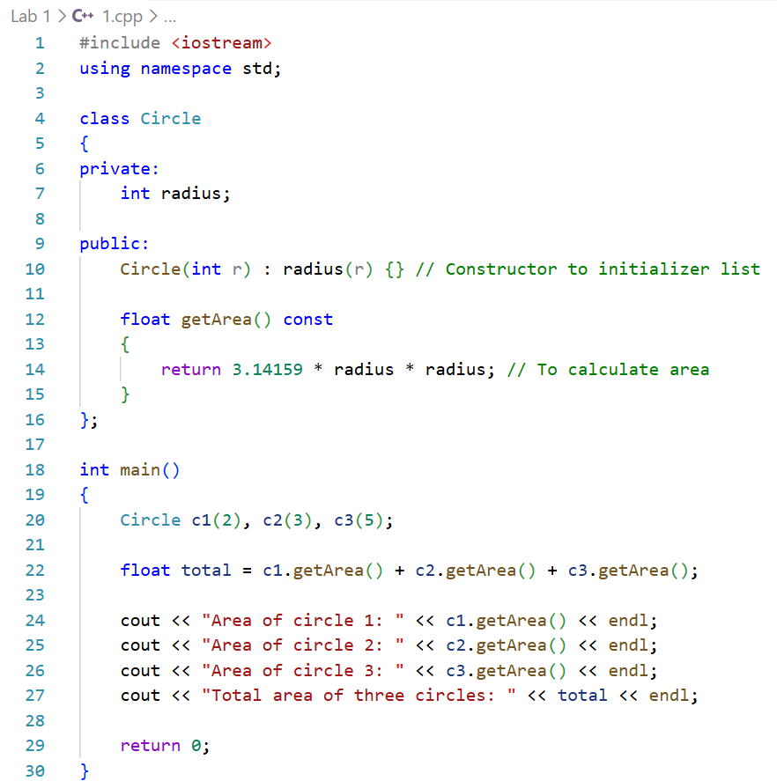
Procedure:
- The Circle class was created with radius as a private member
- A method to calculate area was written
- Three Circle objects were initialized in main
- Individual areas and total area were calculated and displayed
Output:
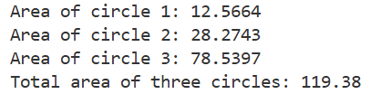
Precautions:
- Radius should be positive
- Formula should be correctly implemented
Conclusion:
The area of each circle and the total area were successfully calculated using the Circle class. Object-oriented programming was demonstrated effectively by handling multiple circle objects with their own data and methods

Problem 2: Account Class
Objectives:
- To create an Account class to simulate banking operations
- To perform deposit, withdrawal, transfer and display balances
Theory:
A bank account has an account number and a balance. Deposit increases the balance, withdrawal decreases it and transfer moves money from one account to another
Code:
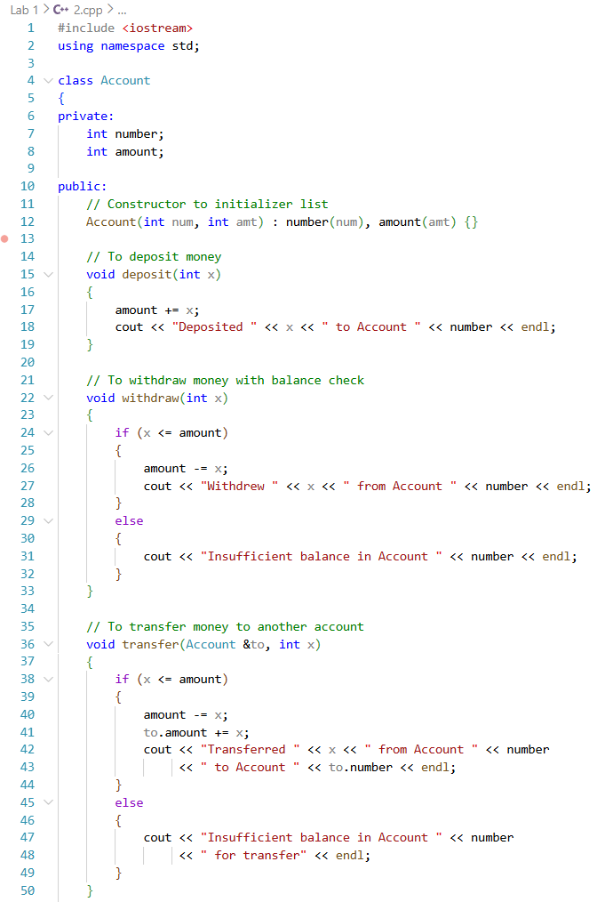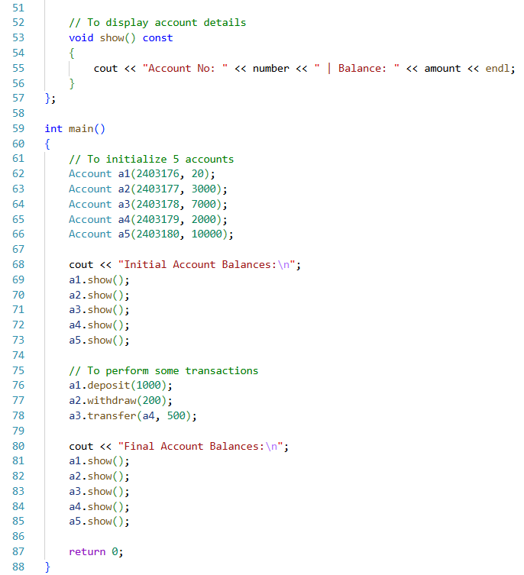
Procedure:
- The Account class was created with account number and balance
- Deposit, withdrawal, transfer and display methods were implemented
- Accounts were initialized in main
- Transactions were performed and final balances were displayed
Output:
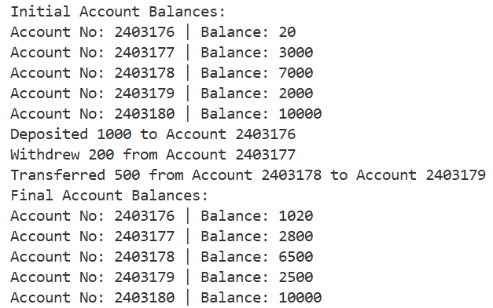
Precautions:
- Ensure withdrawal or transfer amount ≤ balance
- IDs should be unique
Conclusion:
Deposits, withdrawals and transfers were performed successfully. The Account class allowed secure and organized management of balances, demonstrating object-oriented principles in a simple banking system

Problem 3: Triangle Class
Objectives:
- To create a Triangle class
- To initialize edges, check validity and calculate the area
Theory:
A triangle is defined by its three edges. A triangle is valid if the sum of any two edges is greater than the third edge. The area can be calculated using the formula: s = (a+b+c)/2 and Area = sqrt(s*(s-a)*(s-b)*(s-c)). Using a class allows both the edges and the methods for validation and area calculation to be combined in one structure
Code:
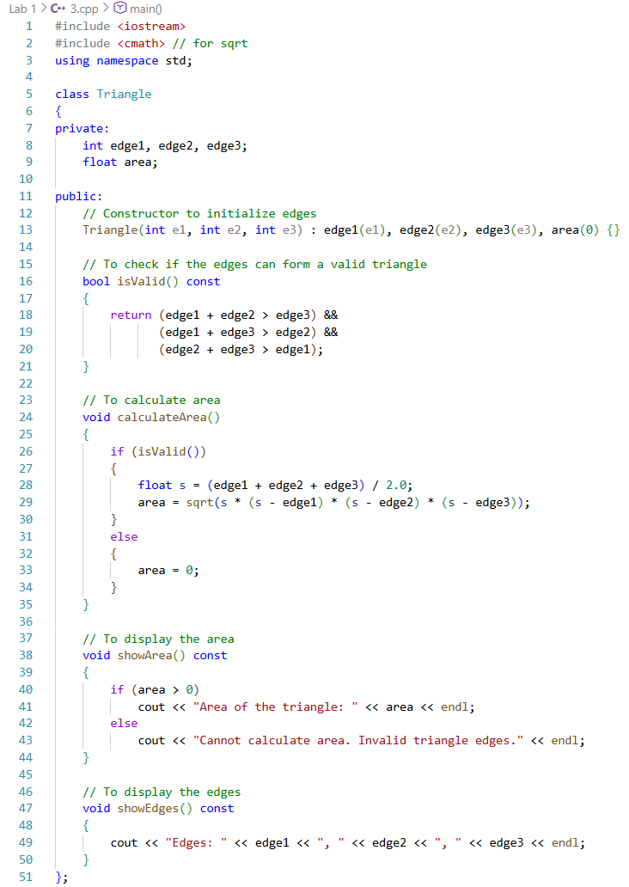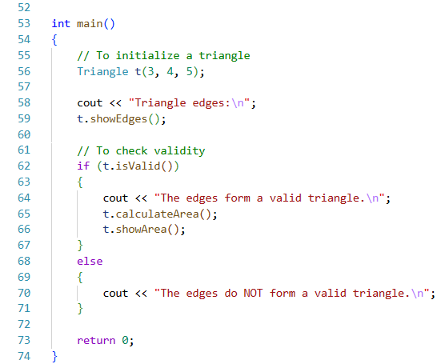
Procedure:
- The Triangle class was created with three edges as private members
- Validity was checked using the triangle inequality rule
- Area was calculated and displayed for valid triangles
Output:
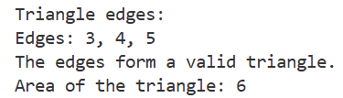
Precautions:
- Edges must be positive
- Check validity before calculating area
Conclusion:
The Triangle class successfully verified triangle validity and calculated its area. Object-oriented principles allowed encapsulation of edges and operations efficiently

Problem 4: Gym Member
Objectives:
- To create a Member class for gym members
- To calculate BMI and classify members’ health status
- To find min, max and average height & weight
Theory:
Each member has an ID, height and weight. BMI is calculated using the formula BMI = Weight / Height² and the member is classified as underweight, normal, overweight, or obese according to standard BMI ranges. Classes make it easy to handle multiple members and perform operations like min, max, average and BMI classification
Code:
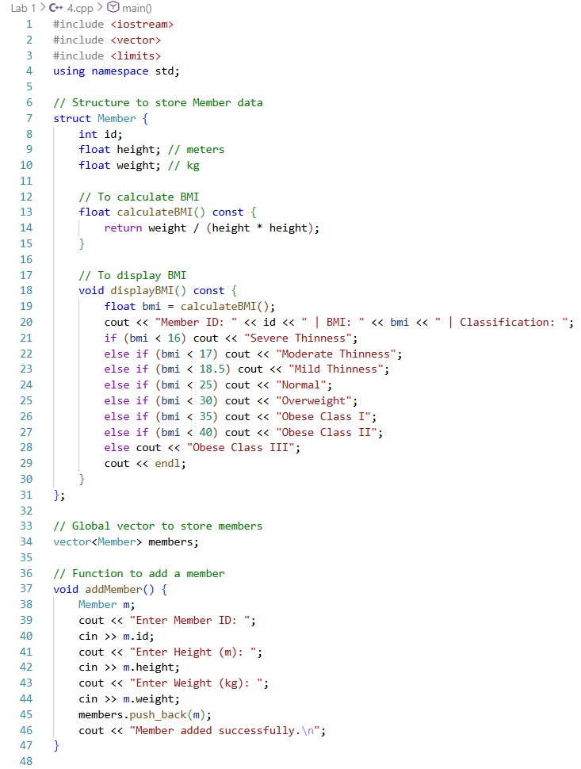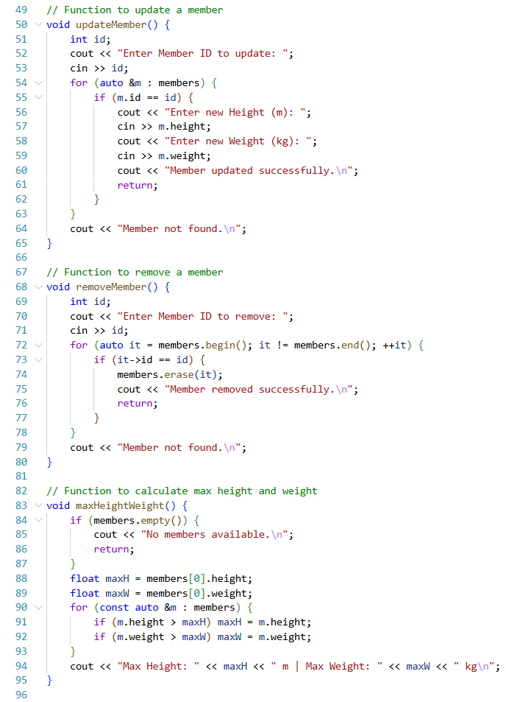
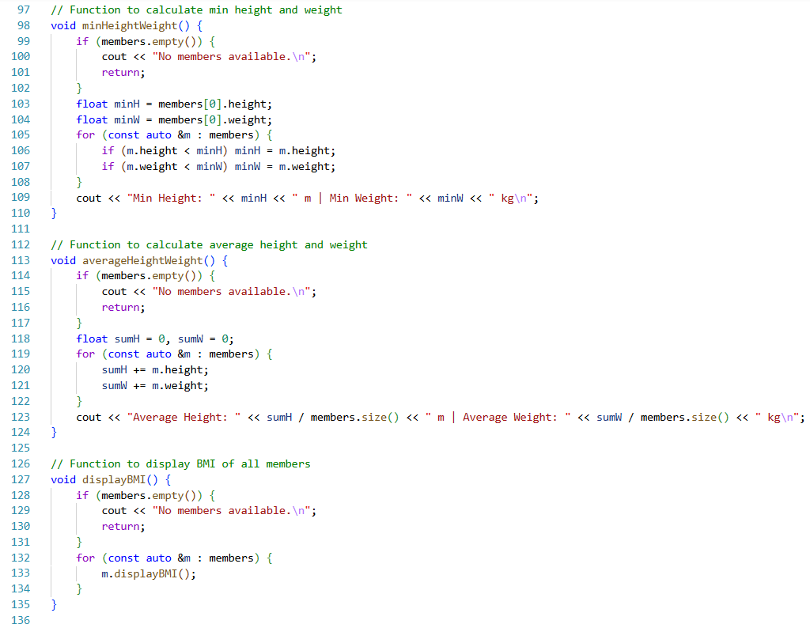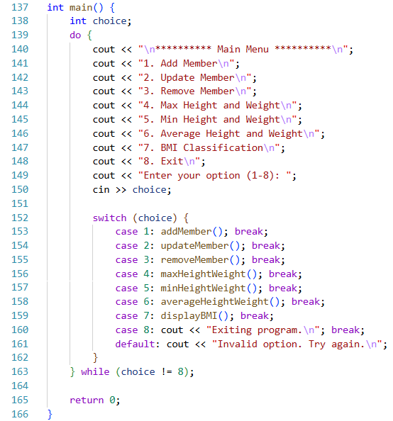
Procedure:
- The Member class was created with ID, height and weight
- Members were added, updated and removed from the system
- BMI was calculated and classification was displayed
- Min, max and average height & weight were calculated and displayed
Output:
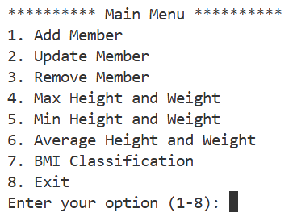
Precautions:
- Enter positive height and weight
- IDs must be unique
Conclusion:
BMI calculations and member management were successfully implemented. Object-oriented programming was used to organize multiple members efficiently and statistical operations were applied accurately

Problem 1: Test Class

Objectives:
- To create a Test class with multiple constructors
- To track the total number of objects created
- To perform operations using object data members

Theory:
In object-oriented programming, constructors are used to initialize objects in different ways such as default, parameterized and copy constructors. A static data member is shared among all objects of a class and is useful for counting how many objects are created. Encapsulation ensures that data members remain protected while methods control access to them

Code:
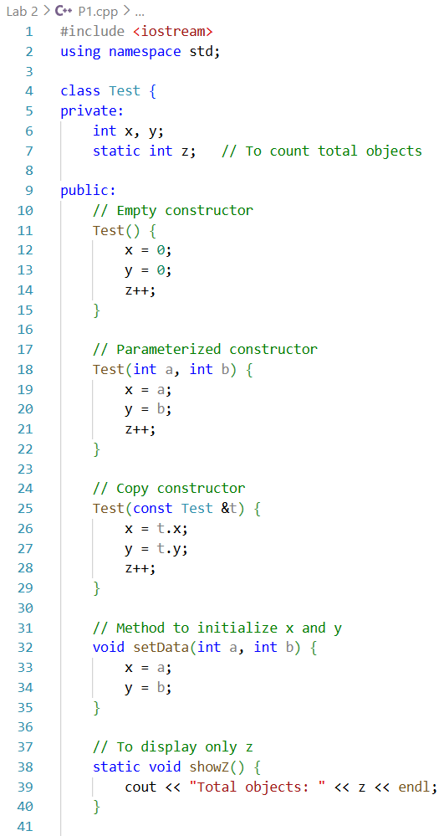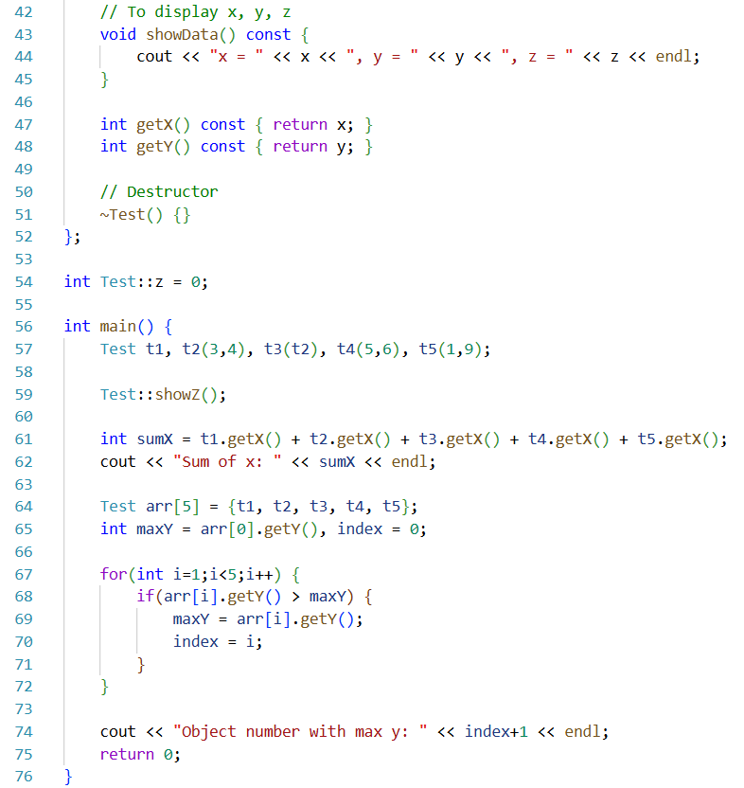

Procedure:
- The Test class was created with private data members x, y and static z
- Constructors were implemented to initialize data in different ways
- Five objects were created using different constructors
- The sum of x values and maximum y value were calculated
- Destructor was defined for object cleanup

Output:
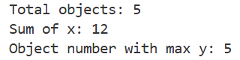

Precautions:
- Static variable must be defined outside the class
- Copy constructor should receive object by reference
- Constant methods should not modify data members

Conclusion:
The Test class successfully demonstrated the use of constructors, static data members and object operations. Object counting and data analysis were performed correctly, showing proper use of object-oriented programming concepts

Problem 2: Copy Constructor

Objectives:
- To create a class with two data members
- To use setter method and copy constructor

Theory:
A copy constructor is used to create a new object by copying data from an existing object. Setter methods help initialize private data members safely. This approach ensures controlled access and proper duplication of object data

Code:
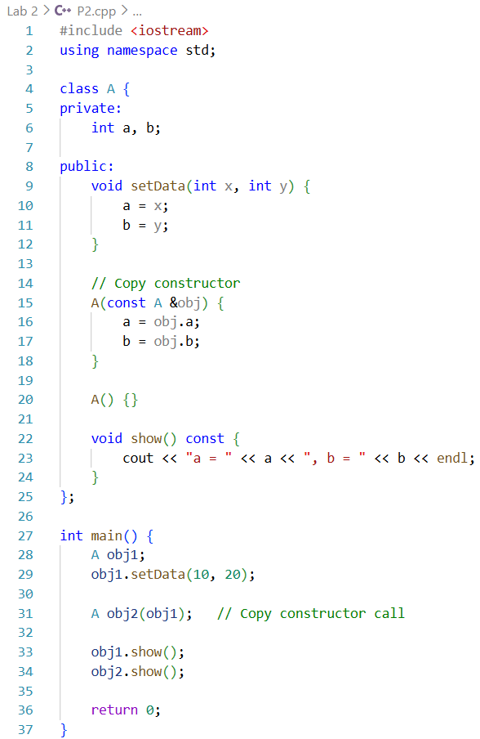

Procedure:
- The class A was created with two private data members
- Setter method was used to assign values to obj1
- Copy constructor was used to copy data from obj1 to obj2
- Values were displayed for verification

Output:
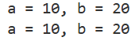

Precautions:
- Copy constructor must accept reference parameter
- Setter method should be used before copying data
- Private members should not be accessed directly

Conclusion:
The program successfully demonstrated the use of setter methods and copy constructors. Object data was copied correctly, ensuring safe and structured duplication of objects

Problem 1: Father → Son → GrandSon Inheritance

Objectives:
- To create a multi-level inheritance hierarchy: Father → Son → GrandSon
- To explore access to private, protected and public members in derived classes
- To calculate the sum of accessible members in GrandSon class

Theory:
Inheritance allows a class to acquire members and methods from another class. Access specifiers (private, protected, public) control which members are accessible in derived classes. Multi-level inheritance demonstrates how access modifiers affect visibility across different levels of hierarchy. By testing various inheritance types, one can see which members are accessible in Son and GrandSon classes and how sums of accessible members can be calculated

Code:
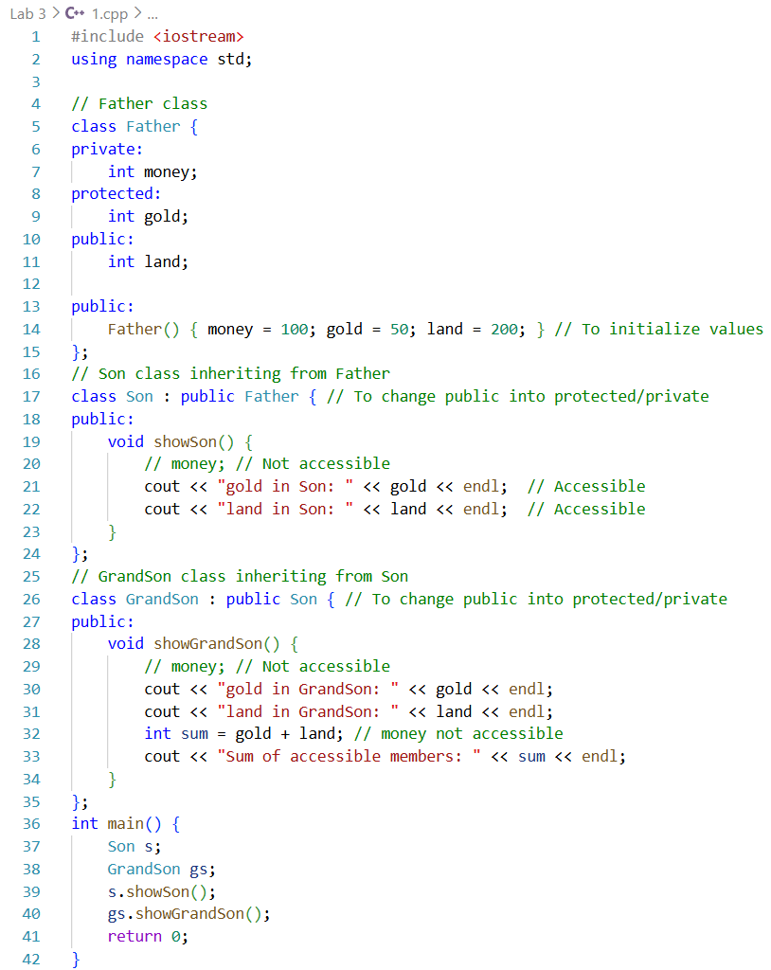

Procedure:
- The Father class was created with private, protected and public members
- The Son class was derived from Father with public inheritance
- The GrandSon class was derived from Son with public inheritance
- Accessible members in Son and GrandSon classes were tested and displayed
- Sum of accessible members in GrandSon class was calculated
- Different inheritance types were tested by modifying access specifiers

Output:
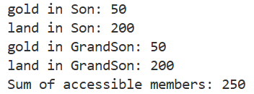
- Son class: gold and land accessible; money not accessible
- GrandSon class: gold and land accessible; money not accessible
- Sum of accessible members in GrandSon class displayed correctly
Class |  | In Son Class |  |  | In GrandSon Class
Son | GrandSon | money | gold | land | money | gold | land
public | public | ✕ | ✓ | ✓ | ✕ | ✓ | ✓
protected | public | ✕ | ✓ | ✕ | ✕ | ✓ | ✕
private | public | ✕ | ✕ | ✕ | ✕ | ✕ | ✕
public | protected | ✕ | ✓ | ✓ | ✕ | ✓ | ✕
protected | protected | ✕ | ✓ | ✕ | ✕ | ✓ | ✕
private | protected | ✕ | ✕ | ✕ | ✕ | ✕ | ✕
public | private | ✕ | ✓ | ✓ | ✕ | ✕ | ✕
protected | private | ✕ | ✓ | ✕ | ✕ | ✕ | ✕
private | private | ✕ | ✕ | ✕ | ✕ | ✕ | ✕

Precautions:
- Private members cannot be accessed in derived classes
- Correct inheritance type must be used based on accessibility requirements
- Display functions should only access allowed members

Conclusion:
The problem demonstrates multi-level inheritance and the effect of different access specifiers. Son and GrandSon classes accessed only allowed members of Father and the sum of accessible members was calculated correctly

Problem 2: Different Types of Inheritance

Objectives:
- To learn and test different types of inheritance in C++
- To access private, protected and public members from derived classes
- To understand visibility rules for each inheritance type

Theory:
Inheritance in C++ allows one class to derive properties and behaviors from another class. There are multiple types:
- Single Inheritance: One base, one derived class
- Multi-Level Inheritance: Chain of inheritance (base → derived → derived)
- Multiple Inheritance: One derived class inherits from multiple base classes
- Hierarchical Inheritance: Multiple derived classes inherit from the same base
- Hybrid Inheritance: Combination of more than one type of inheritance
Access specifiers (private, protected, public) control which members are visible in derived classes

Codes:

Single Inheritance
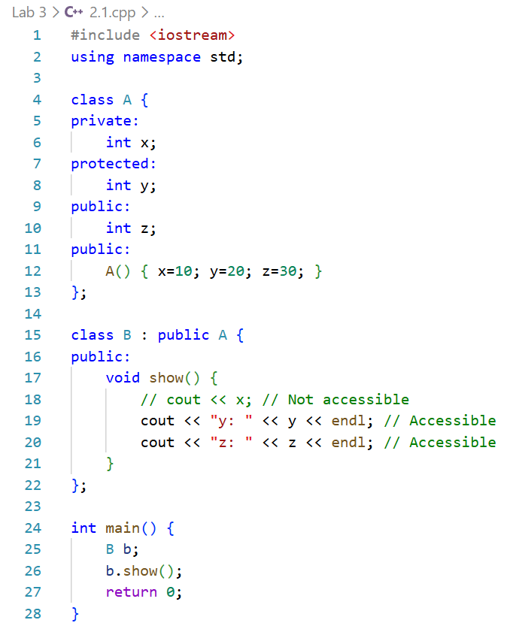
Output:
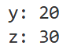

Multi-Level Inheritance
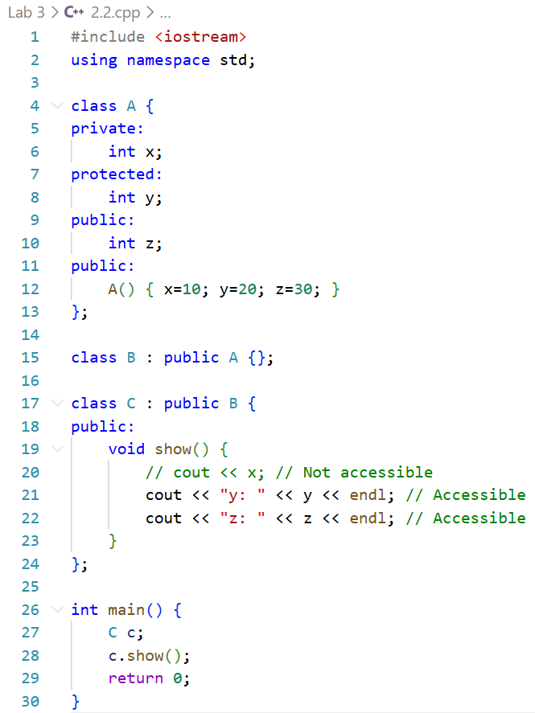

Output:

Multiple Inheritance
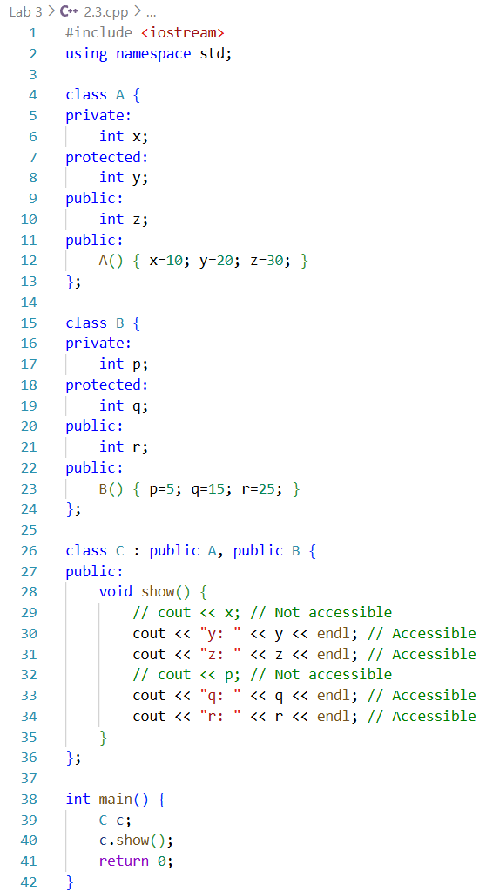
Output:
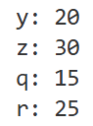

Hierarchical Inheritance
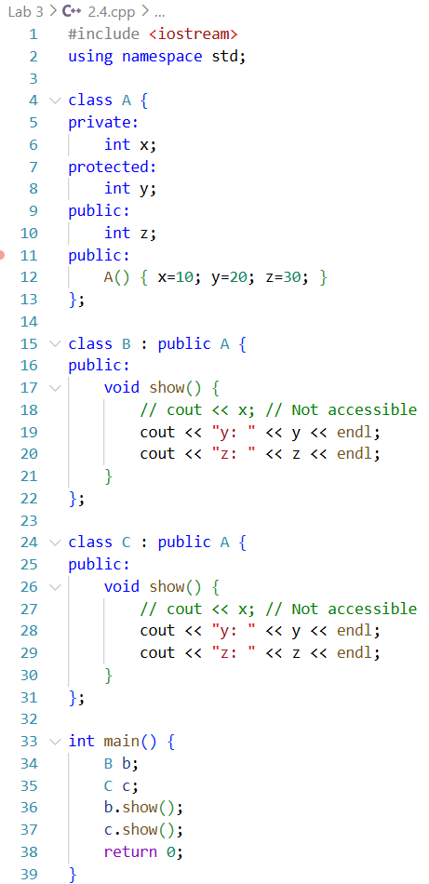
Output:
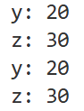

Hybrid Inheritance
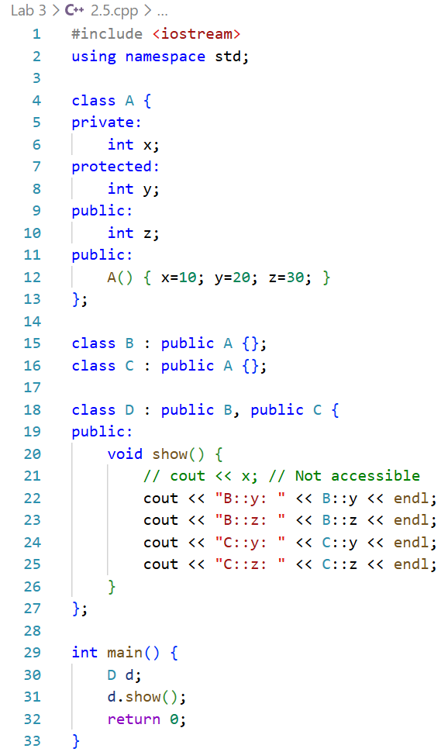
Output:
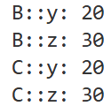

Procedure:
- Classes were created according to the inheritance type
- Derived class methods were written to access base class members
- main() called the methods to observe accessible members
- Each inheritance type was tested separately
- Output: was noted for private, protected and public members

Observations:
- Private members of base classes were never accessible in derived classes
- Protected members were accessible in derived classes depending on inheritance type
- Public members were accessible in public inheritance
- Different inheritance types demonstrated different member accessibilities

Precautions
- Private members cannot be accessed directly in derived classes
- Correct inheritance type must be used for expected access
- Display functions should not try to access inaccessible members

Conclusion
The problem successfully demonstrated all five types of inheritance in C++. Access specifiers correctly controlled visibility in derived classes. Multi-level, multiple, hierarchical and hybrid inheritance types were successfully tested, showing how inheritance type and access specifiers influence accessibility

Problem 3: Constructors & Destructors in Inheritance

Objectives:
- To understand constructor and destructor execution in different types of inheritance.
- To implement constructors and destructors for single, multi-level, multiple, hierarchical and hybrid inheritance.
- To observe and verify the sequence of constructor and destructor calls.

Theory:
In C++, constructors are executed from base class to derived class, while destructors are executed from derived class to base class

Single Inheritance

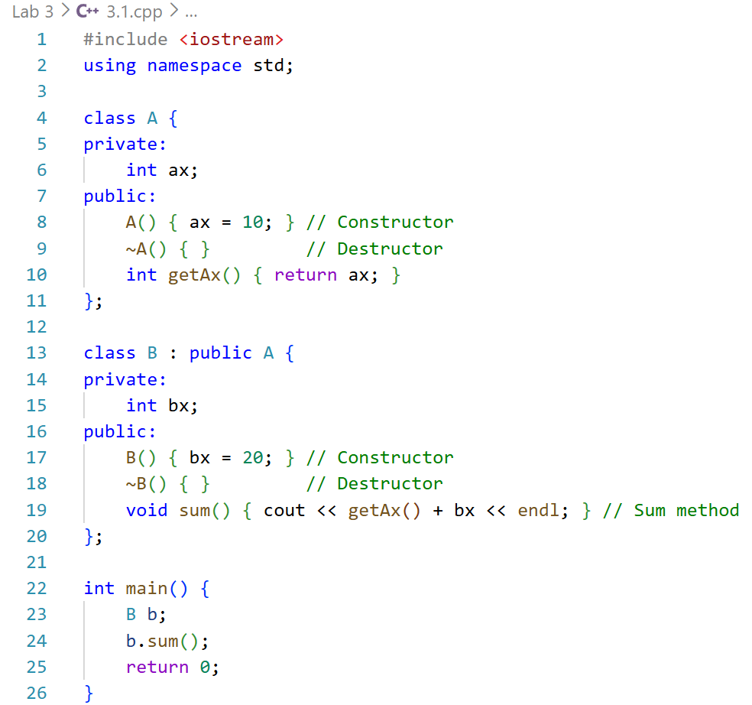
Sequence:
Constructor: A → B
Destructor: B → A
- Multi-Level Inheritance
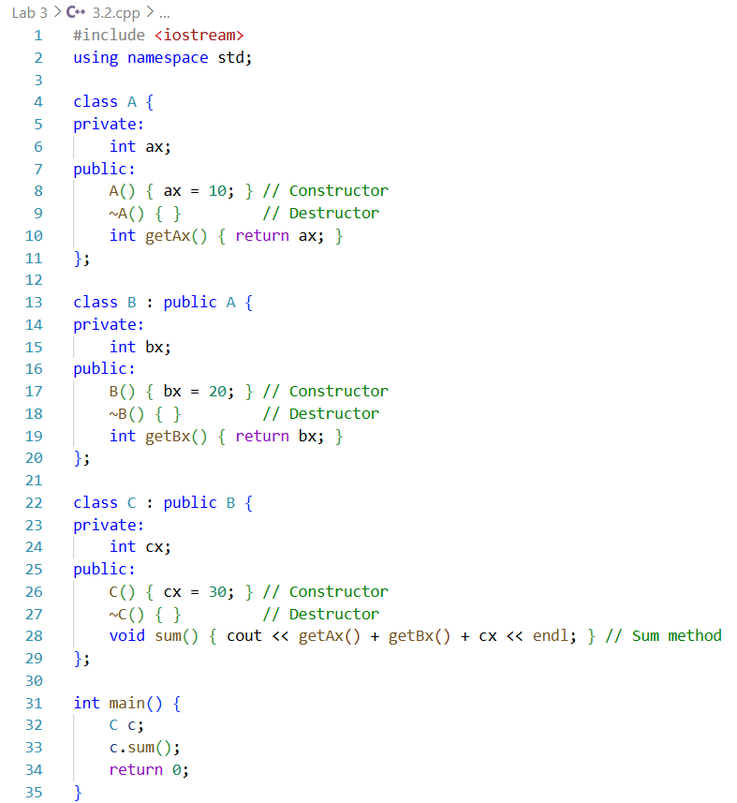
Sequence:
Constructor: A → B → C
Destructor: C → B → A
- Multiple Inheritance
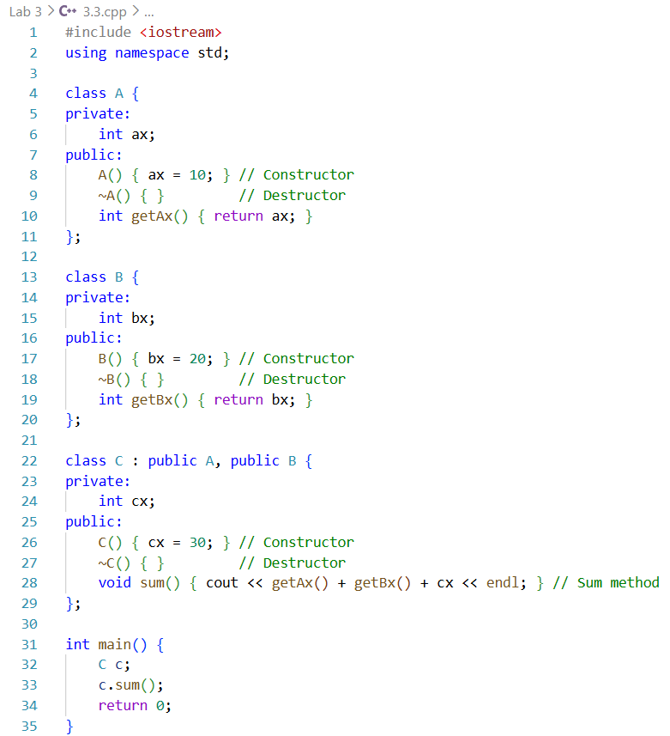
Sequence:
Constructor: A → B → C
Destructor: C → B → A
- Hierarchical Inheritance
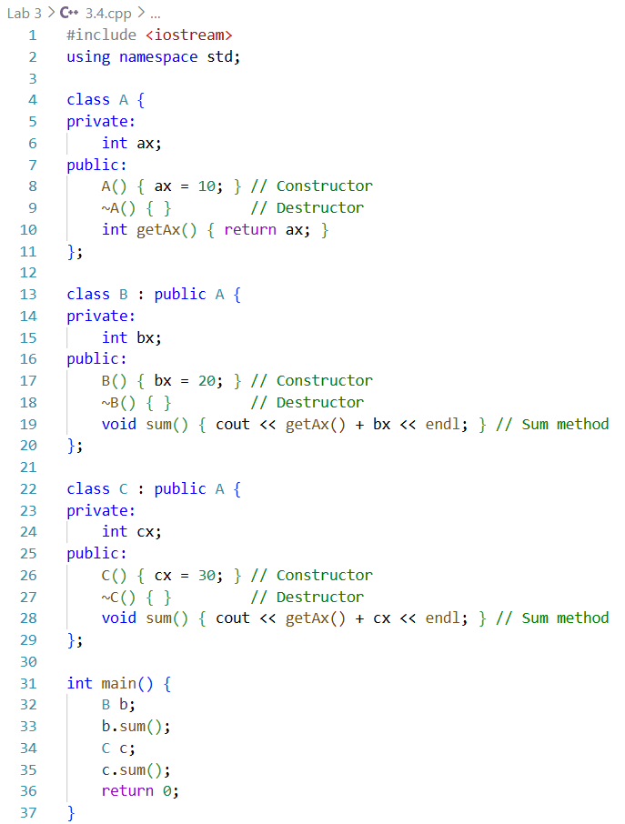
Sequence:
For B: Constructor A → B, Destructor B → A
For C: Constructor A → C, Destructor C → A

Hybrid Inheritance
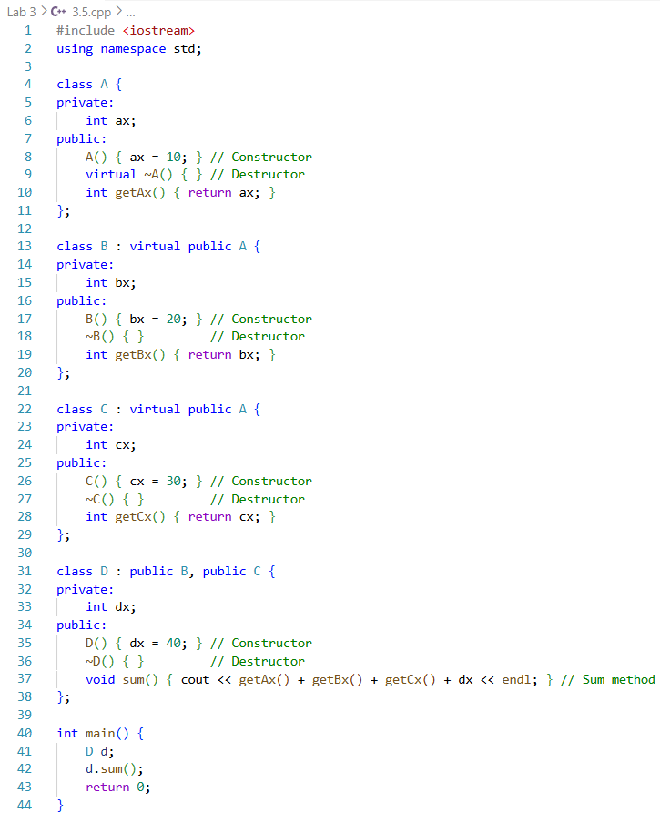
Sequence:
Constructor: A → B → C → D
Destructor: D → C → B → A

Procedure:
- Classes were created with private members and constructors/destructors
- Derived classes implemented their own constructors and destructors
- Methods were written to calculate the sum of all relevant members
- main() objects were created to observe constructor/destructor sequences
- Execution order of constructors and destructors was noted for each inheritance type

Output:
- Constructors always executed from base → derived
- Destructors executed in reverse: derived → base
- Virtual inheritance ensured single construction of shared base class in diamond problem
- Sum methods returned correct results using accessible members

Precautions:
- Always initialize base members properly
- In multiple inheritance, constructors for each base must be correctly called
- For diamond inheritance, use virtual to prevent multiple base construction

Conclusion:
Constructors and destructors in inheritance follow strict sequences: base to derived for construction and derived to base for destruction. This problem demonstrated constructor/destructor execution clearly for single, multi-level, multiple, hierarchical and hybrid inheritance types

Problem 1: Method / Function Overloading

Objectives:
- To implement function overloading using a single method name
- To perform summation of different types and numbers of values

Theory:
Function overloading allows multiple functions to have the same name but different parameter lists. The compiler decides which function to call based on the number and type of arguments passed. This improves code readability and flexibility by using one logical function name for related operations

Code:
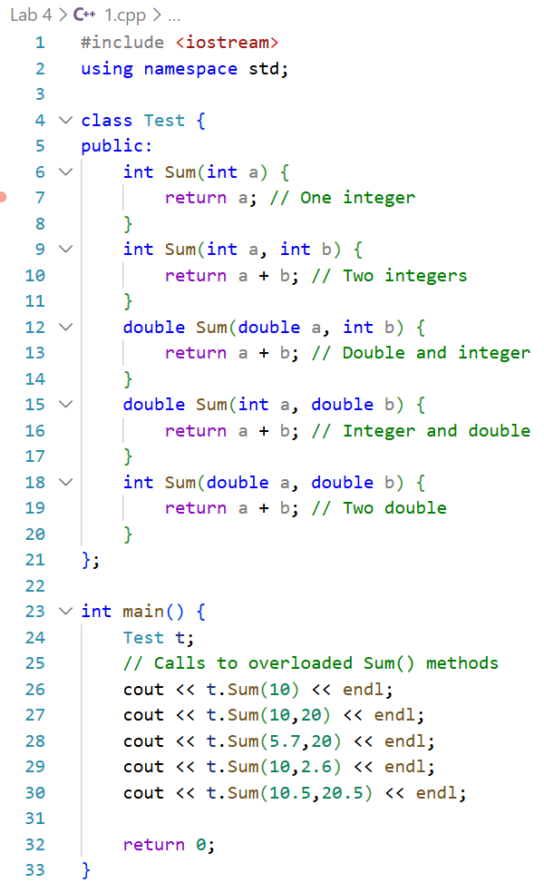

Procedure:
- A Test class was created
- The Sum() method was overloaded with different parameter types
- Function calls were made from main()
- Returned values were displayed

Output:
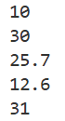
- Sum(10) → 10
- Sum(10,20) → 30
- Sum(5.7,20) → 25.7
- Sum(10,2.6) → 12.6
- Sum(10.5,20.5) → 31

Precautions:
- Parameter types must differ clearly
- Return type alone should not differ
- Proper data types must be used

Conclusion:
Function overloading was implemented successfully. The program correctly selected the appropriate Sum() method based on function arguments, demonstrating compile time polymorphism

Problem 2: Operator Overloading

Objectives:
- To calculate current in an AC circuit using operator overloading
- To represent complex numbers using a class

Theory:
In AC circuits, impedance and voltage are represented as complex numbers. Operator overloading allows arithmetic operations on user defined objects like complex numbers. This simplifies calculations and makes the code more intuitive and readable

Code:
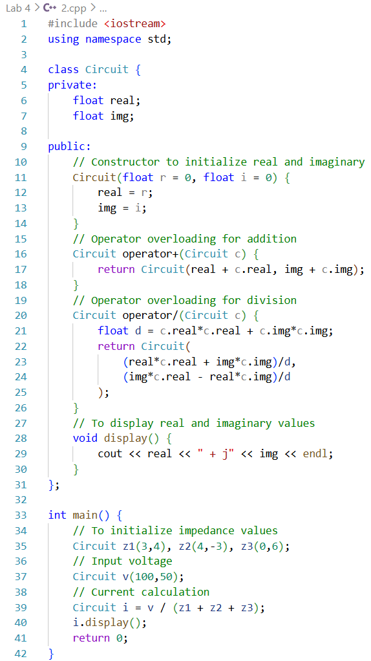

Procedure:
- The Circuit class was created to represent complex numbers
- Operators were overloaded for addition and division
- Impedances and voltage were initialized
- Current was calculated and displayed

Output:
- Complex arithmetic was performed correctly
- Current value was obtained using overloaded operators

Precautions:
- Division by zero must be avoided
- Correct formula for complex division should be used

Conclusion:
Operator overloading simplified complex number calculations. The circuit current was computed correctly, demonstrating effective use of operator overloading

Problem 3: Unary Operator Overloading

Objectives:
- To control TV sound using unary operator overloading.
- To increase and decrease sound using operators.

Theory:
Unary operator overloading allows operators like ++ and -- to be redefined for user-defined classes. This is useful for controlling incremental changes such as sound level in a TV remote system.

Code:
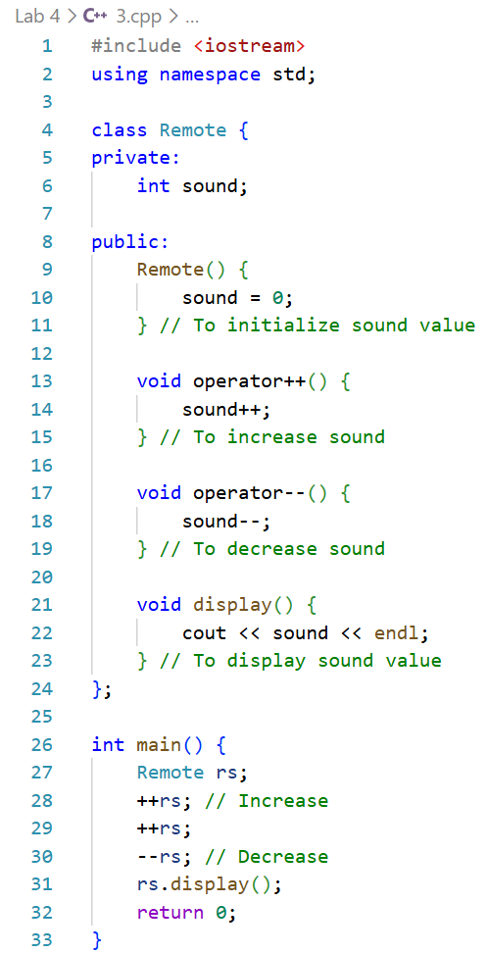

Procedure:
- A Remote class was created
- Unary operators ++ and -- were overloaded
- Sound level was increased and decreased
- Final sound value was displayed

Output:
- Sound increased on ++ operation
- Sound decreased on -- operation
- Final sound level displayed correctly

Precautions:
- Sound should not exceed limits
- Initial sound value should be defined

Conclusion:
In this problem, Unary operator overloading was implemented successfully to control the sound levels of a TV remote. Each operator (++ and --) correctly modified the private sound data member as intended, simulating the increase and decrease of volume. The program demonstrated how unary operators can be customized for user-defined classes, and the final output verified that the remote responded accurately to multiple button presses. This exercise reinforced the concept of operator overloading and showed its practical application in modeling real-world devices

Problem 4: Friend Function

Objectives:
- To calculate total money using friend function
- To access private data members of two classes

Theory:
Friend functions are special functions in C++ that are granted access to the private and protected members of one or more classes. This capability is particularly useful when operations require combining or manipulating data from multiple classes while still preserving the principles of encapsulation and data hiding, allowing controlled interaction between class internals without exposing them publicly

Code:
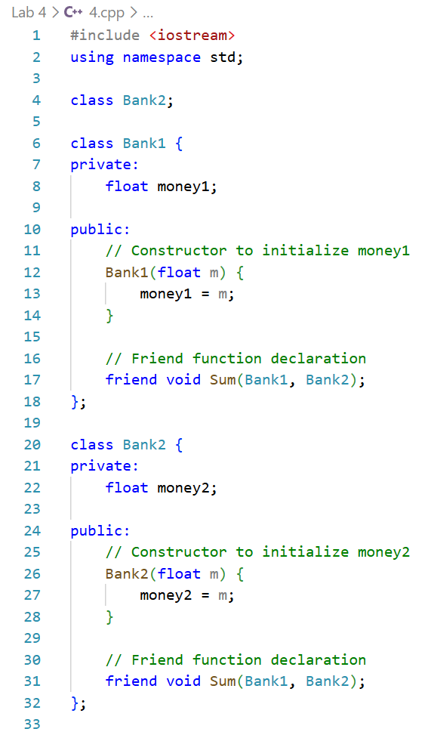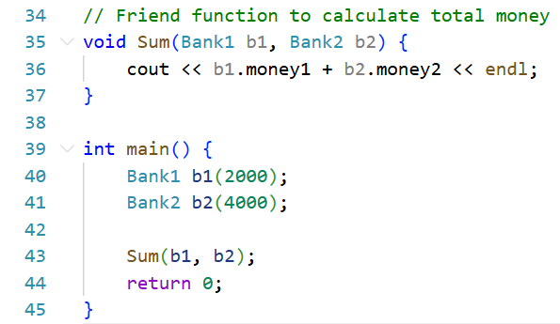

Procedure:
- Two bank classes were created with private money variables
- A friend function was declared and defined
- Total money was calculated and displayed

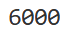
Output:
- Correct total money was displayed
- Private data was accessed successfully

Precautions:
- Friend functions should be used carefully
- Class relationships should be clear

Conclusion:
The friend function successfully accessed private data members from two classes. Total money calculation was performed correctly, demonstrating controlled data sharing

Problem 1: Method/Function Overriding
Objectives:
- To understand the concept of method/function overriding in C++ inheritance
- To observe the effect of the virtual keyword on runtime polymorphism
Theory:
In C++, a derived class can provide its own implementation of a base class method, which is called function overriding. When a base class pointer points to a derived class object, the behavior differs depending on whether the base class method is declared virtual. Using virtual enables runtime polymorphism, allowing the correct overridden method to be called.
Code:
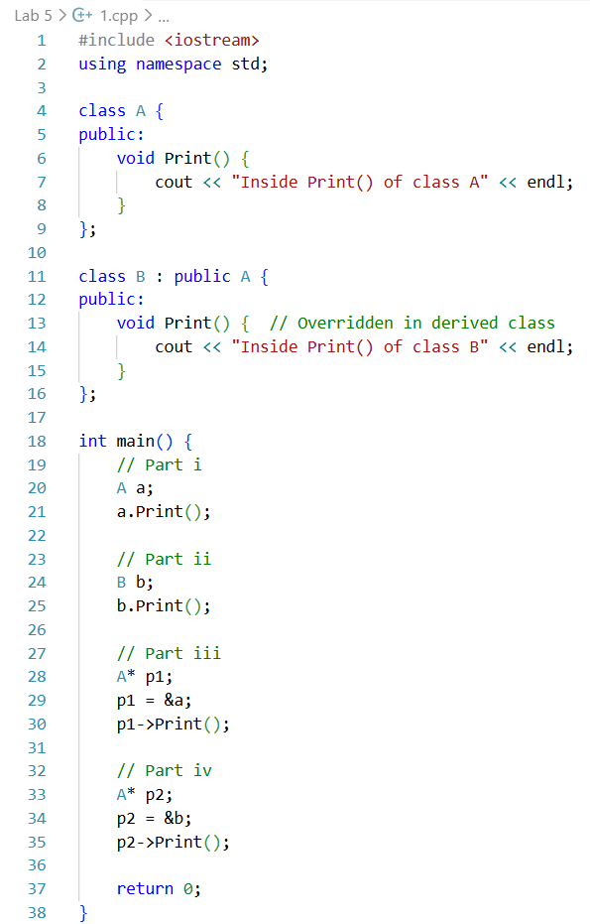
Procedure:
- Base class A was created with method Print()
- Derived class B was created, and its Print() method was overridden
- Objects of A and B were initialized, and their Print() methods were called (parts i and ii)
- Base class pointers were assigned to A and B objects, and the Print() methods were called (parts iii and iv)
- The output was observed without the virtual keyword to note which method was called.
- The virtual keyword was added to Print() in class A
- Steps 3-4 were repeated, and the output was observed for runtime polymorphism
Output:
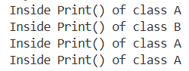
Precautions:
- Correct inheritance syntax class B: public A was ensured
- Method signatures were matched exactly during overriding (same name, parameters, and return type)
Conclusion:
Function overriding allowed the derived class to provide its own implementation of the base class method. By adding the virtual keyword in the base class, runtime polymorphism was achieved, enabling the correct derived class method to execute when base class pointers were used. This demonstrated dynamic binding in C++ inheritance
Problem 2: Pure Virtual Function
Objectives:
- To understand the concept of pure virtual functions and abstract classes in C++
- To observe how derived classes implement abstract methods and enable runtime polymorphism
Theory:
A pure virtual function in C++ is declared by assigning 0 in its declaration (virtual void func() = 0). A class containing at least one pure virtual function becomes an abstract class, which cannot be instantiated. Derived classes must provide implementations for pure virtual functions to become concrete and usable objects
Code:
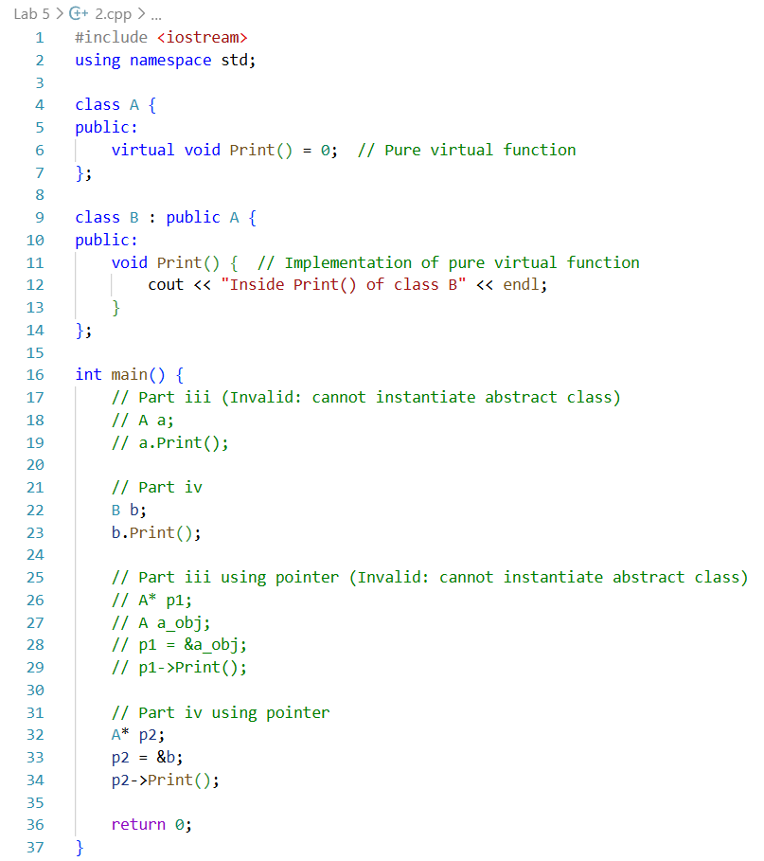
Procedure:
- Abstract class A was created with a pure virtual function Print()
- Derived class B was created, and Print() was implemented in it
- Objects of A were not instantiated since A was abstract
- Object of B was initialized, and its Print() method was called
- Base class pointers were assigned to B objects, and the Print() method was invoked to demonstrate runtime polymorphism
- Attempts to instantiate abstract class A were avoided to prevent compilation errors
Output:
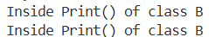
Precautions:
- Abstract classes were not instantiated, as it is illegal in C++
- Pure virtual functions were correctly implemented in derived classes to avoid errors
Conclusion:
The use of pure virtual functions enforced that derived classes provide specific implementations for abstract methods. Runtime polymorphism was achieved using base class pointers pointing to derived class objects, demonstrating dynamic binding and abstract class behavior in C++
Problem 3: Exception Handling
Objectives:
- To understand the use of exception handling in C++ to manage runtime errors
- To implement multiple catch blocks to handle different types of exceptions
Theory:
Exception handling in C++ allows programs to manage runtime errors without crashing. Using try, throw, and catch blocks, specific exceptions can be detected and handled. Multiple catch blocks can handle different types of exceptions, and a default catch() block can catch all unhandled exceptions
Code:
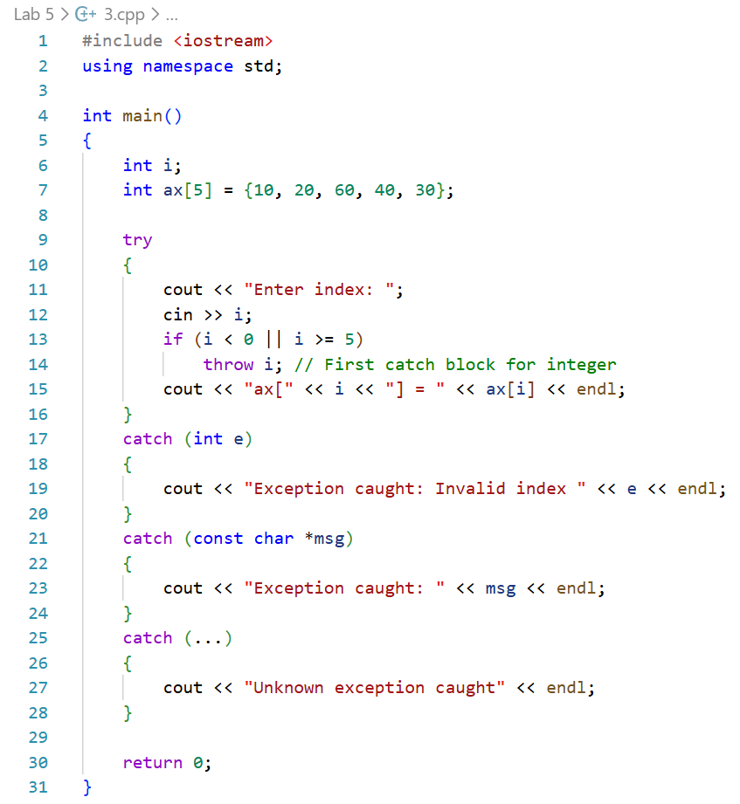
Procedure:
- Array ax[] was initialized with five integer elements
- User input was requested to obtain the array index i
- The try block was used to access ax[i]
- Index validation was performed, and i was thrown as an exception if out of range
- First catch block was written to receive the integer value of i
- Second catch block was written to handle a string message "Out of Range Error"
- Default catch() block was written to handle any other unhandled exceptions
Output:
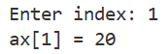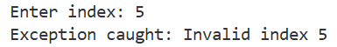
Precautions:
- Array bounds were checked before accessing elements to prevent runtime errors
- Appropriate exception types were thrown and caught to ensure program stability
Conclusion:
Exception handling successfully captured out-of-range index errors and prevented program termination. Multiple catch blocks allowed handling of different exception types, demonstrating robust runtime error management in C++
Problem 4: STL: Array
Objectives:
- To understand the use of STL array and its member functions in C++
- To perform various operations on an array object like access, fill, size, and address retrieval
Theory:
The STL array in C++ is a container that encapsulates fixed-size arrays with additional member functions. Functions like at(), front(), back(), fill(), empty(), size(), max_size(), begin(), and end() allow safe and convenient operations on arrays, enhancing functionality over traditional C-style arrays
Code:
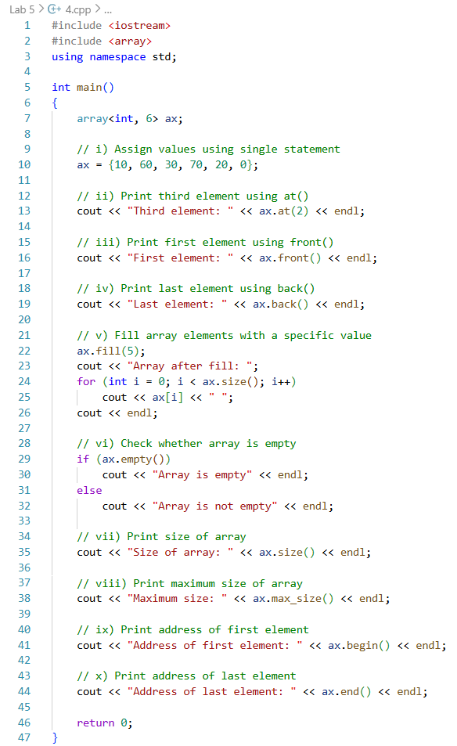
Procedure:
- STL array ax was declared with 6 elements
- Values 10, 60, 30, 70, 20, 0 were assigned using a single statement
- Third element was accessed and printed using at()
- First element was accessed using front() and printed
- Last element was accessed using back() and printed
- All elements of the array were filled using fill() function
- Array emptiness was tested using empty() function
- Size of the array was printed using size()
- Maximum possible size of the array was printed using max_size()
- Address of the first element was printed using begin()
- Address of the last element was printed using end()
Output:
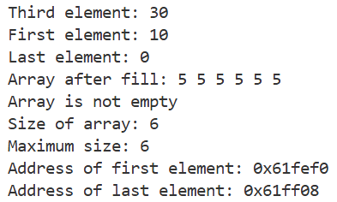
Precautions:
- Array indices were ensured to be within valid range to avoid runtime errors
- Correct STL array functions were used according to their syntax and functionality
Conclusion:
STL array provided a convenient and safe way to store and manipulate fixed-size elements. Member functions like at(), front(), back(), fill(), empty(), size(), max_size(), begin(), and end() were successfully demonstrated, showing the advantages of STL arrays over traditional arrays
Problem 5: STL: Pair Class
Objectives:
- To understand the use of STL pair class for storing two heterogeneous data elements
- To perform operations like assignment, access, modification, and swapping of pair objects
Theory:
The STL pair class allows two values of possibly different types to be stored together as a single object. Members first and second are used to access the elements. Functions like make_pair(), get<>(), and swap() allow assignment, modification, and exchange of pair objects efficiently
Code:
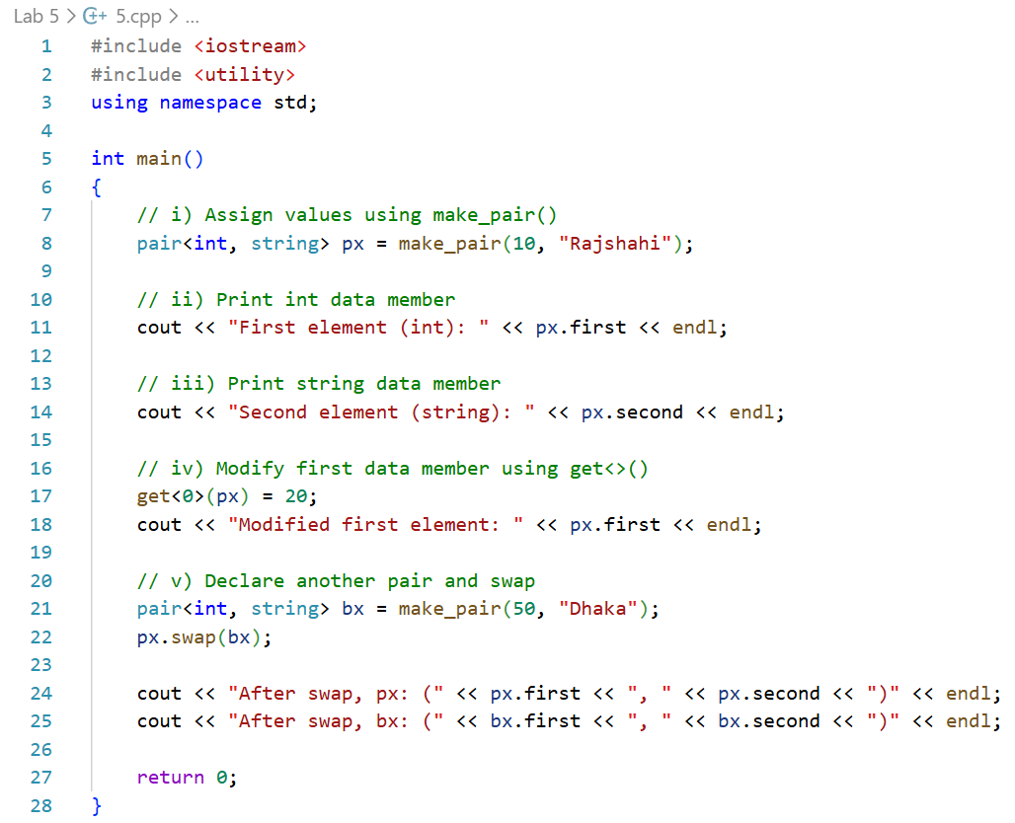
Procedure:
- Pair object px was declared with int and string types
- Values 10 and "Rajshahi" were assigned using make_pair()
- Integer member was accessed and printed using first
- String member was accessed and printed using second
- First data member was modified to 20 using get<>()
- Another pair object bx was declared and initialized with values
- Pair objects px and bx were swapped using swap() function
- The results after swapping were printed to verify correctness
Output:
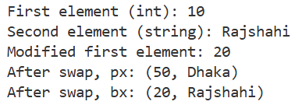
Precautions:
- Correct data types were ensured for both elements while declaring the pair
- Proper STL functions (make_pair(), get<>(), swap()) were used to avoid syntax or runtime errors
Conclusion:
STL pair provided a convenient way to store two heterogeneous elements together. Assignment, access, modification, and swapping of pairs were successfully demonstrated, showing the efficiency and versatility of the pair class in C++
Problem 6: STL: Tuple Class
Objectives:
- To understand the use of STL tuple class for storing multiple heterogeneous data elements
- To perform operations like assignment, access, modification, and swapping of tuple objects
Theory:
The STL tuple class allows storing multiple elements of different types in a single object. Elements are accessed and modified using the get<>() function. Tuples can also be swapped with other tuples using the swap() function, making them flexible for managing heterogeneous data together
Code:
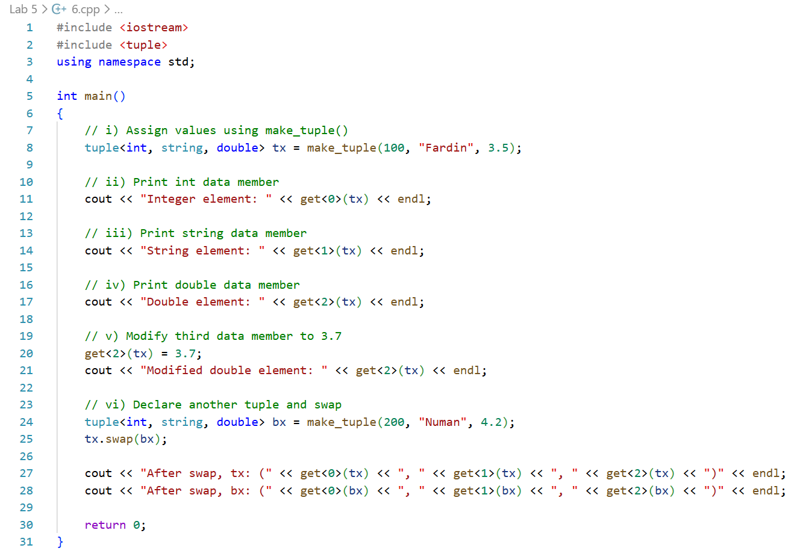
Procedure:
- Tuple object tx was declared with int, string, and double types
- Values <100, "Kamal", 3.5> were assigned using make_tuple()
- First element was accessed and printed using get<0>()
- Second element was accessed and printed using get<1>()
- Third element was accessed and printed using get<2>()
- Third element was modified to 3.7 using get<2>()
- Another tuple object bx was declared and initialized with values
- Tuples tx and bx were swapped using swap() function
- The results after swapping were printed to verify correctness
Output:
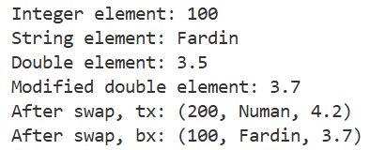
Precautions:
- Correct data types were ensured while declaring the tuple to avoid type mismatch
- get<>() function was used with the correct index to access or modify elements
Conclusion:
STL tuple allowed storing multiple heterogeneous elements in a single object. Assignment, access, modification, and swapping were successfully demonstrated, showing the efficiency and flexibility of tuples in C++
Problem 1: STL: Stack Class
Objectives:
- To understand the use of STL stack class for managing data in LIFO (Last In, First Out) order
- To implement stack operations like push, pop, top, and empty using menu-driven programming
Theory:
The STL stack class in C++ provides a container adapter to store elements in LIFO order. Functions like push(), pop(), top(), and empty() allow efficient insertion, deletion, access, and status checking of the stack. Menu-driven programs enable dynamic user interaction with stack operations
Code:
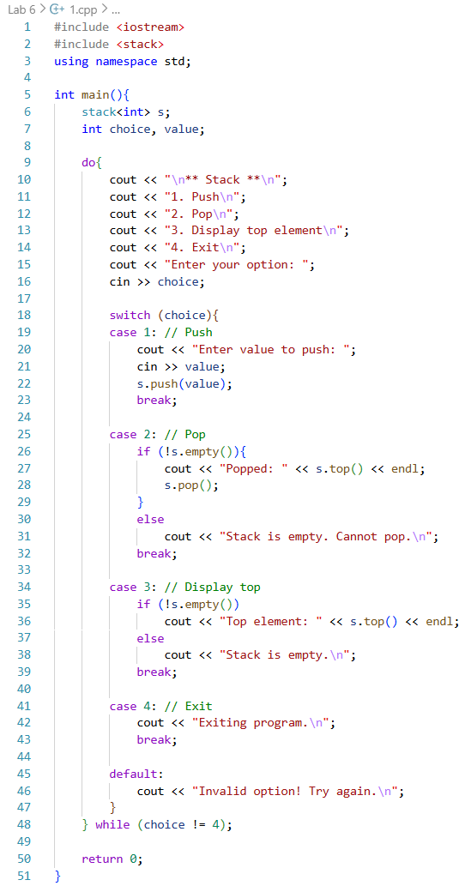
Procedure:
- Stack object s was declared using STL stack class.
- A menu-driven loop was created to take user input repeatedly until exi
- User was prompted to push a value, which was added using push()
- pop() was used to remove the top element when requested, after checking that the stack was not empty
- top() was used to display the top element, provided the stack was not empty
- empty() function was used to check whether the stack had any elements
- Loop continued until the user selected the exit option
Output:
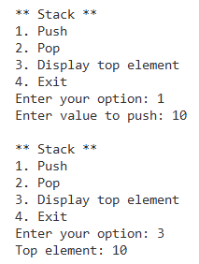
Precautions:
- Stack underflow was prevented by checking empty() before performing pop() or top()
- Valid menu options were ensured to prevent incorrect program behavior
Conclusion:
STL stack provided an efficient way to manage data in LIFO order. Menu-driven programming allowed dynamic interaction, and functions like push(), pop(), top(), and empty() were successfully demonstrated, ensuring correct stack manipulation and error handling.
Problem 2: STL: Queue Class
Objectives:
- To understand the use of STL queue class for managing data in FIFO (First In, First Out) order
- To implement queue operations like enqueue, dequeue, front, back, and empty using menu-driven programming
Theory:
The STL queue class in C++ is a container adapter that stores elements in FIFO order. Functions like push(), pop(), front(), back(), and empty() allow efficient insertion, deletion, access to front and rear elements, and status checking of the queue. Menu-driven programs facilitate dynamic interaction with queue operations
Code:
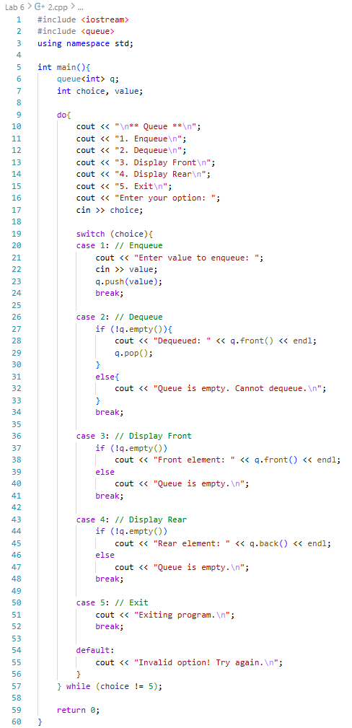
Procedure:
- Queue object q was declared using STL queue class
- A menu-driven loop was created to take user input repeatedly until exit
- User input was taken to enqueue a value, which was added using push()
- pop() was used to remove the front element after verifying that the queue was not empty
- front() was used to display the front element of the queue, provided it was not empty
- back() was used to display the rear element of the queue
- empty() function was used to check whether the queue contained any elements
- The menu loop continued until the user selected the exit option
Output:
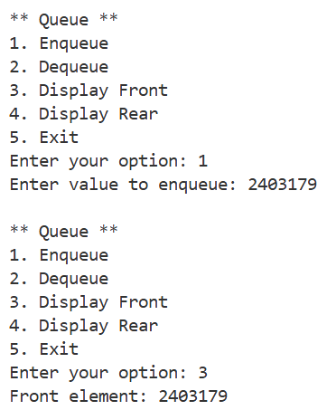
Precautions:
- Queue underflow was prevented by checking empty() before performing pop(), front(), or back()
- Valid menu options were ensured to avoid incorrect program execution
Conclusion:
STL queue allowed efficient management of data in FIFO order. Menu-driven programming enabled dynamic interaction with the queue, and functions like push(), pop(), front(), back(), and empty() were successfully demonstrated, ensuring correct queue operations and error handling
Problem 3: STL: Vector Class
Objectives:
- To understand the use of STL vector class to simulate linked list operations in C++
- To implement vector operations like insertion, deletion, access, and modification using a menu-driven program
Theory:
The STL vector class in C++ is a dynamic array that can grow or shrink at runtime. Functions like push_back(), insert(), erase(), begin(), end(), pop_back(), and pop_front() allow flexible management of elements. Vectors can simulate linked list behavior for insertion, deletion, updating, and searching operations efficiently
Code:
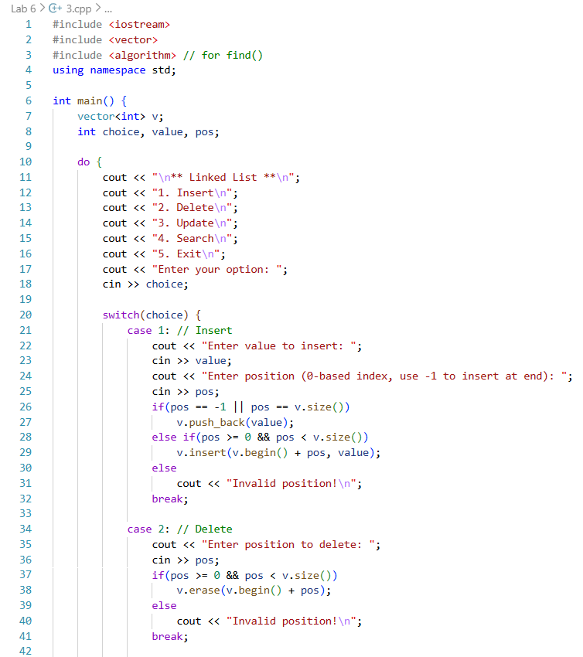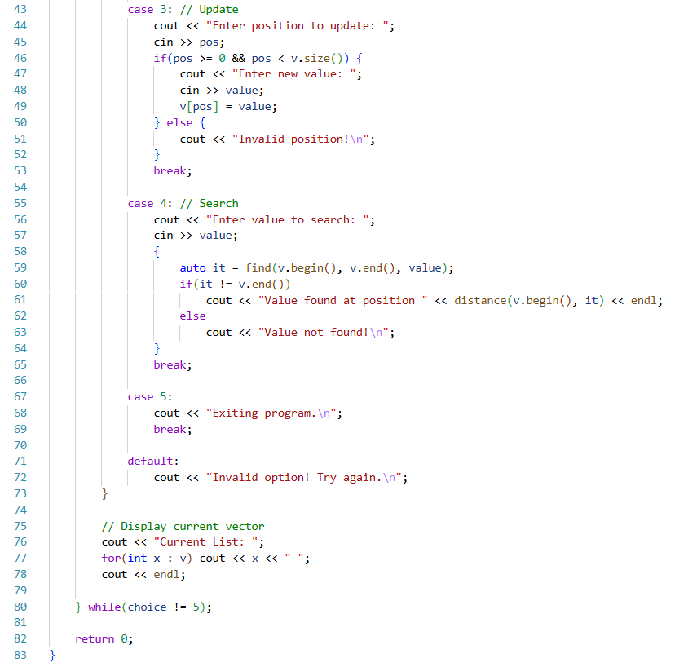
Procedure:
- Vector object v was declared to store integer elements dynamically.
- A menu-driven loop was created to allow multiple operations until exit.
- insert() was used to add elements at user-specified positions.
- erase() was used to delete elements at specified positions.
- Elements were updated directly by accessing them using the index.
- find() along with begin() and end() was used to search for a value in the vector.
- push_back() was implicitly used if inserting at the end of the vector.
- The current state of the vector was displayed after each operation to show changes.
Output:
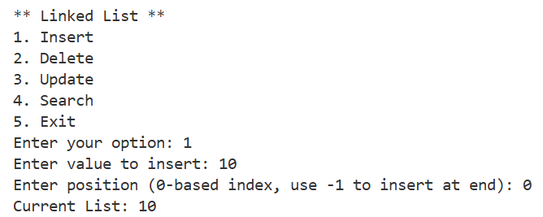
Precautions:
- Valid positions were ensured before performing insert(), erase(), or update() to avoid runtime errors
- Vector functions were used correctly according to their syntax to prevent invalid operations
Conclusion:
STL vector successfully simulated linked list operations like insertion, deletion, updating, and searching. Menu-driven programming allowed dynamic interaction, and vector functions such as insert(), erase(), begin(), and end() were demonstrated effectively for element management
Problem 1: UML
Objectives:
- To understand the structure of a class and its members using UML (Unified Modeling Language)
- To represent data members and member functions of a class visually
Theory:
UML (Unified Modeling Language) is a standardized way to visualize the design of a system. For classes, UML diagrams show data members (private, protected, public) and member functions along with their access specifiers, making it easier to understand the structure and relationships of a class.
Code:
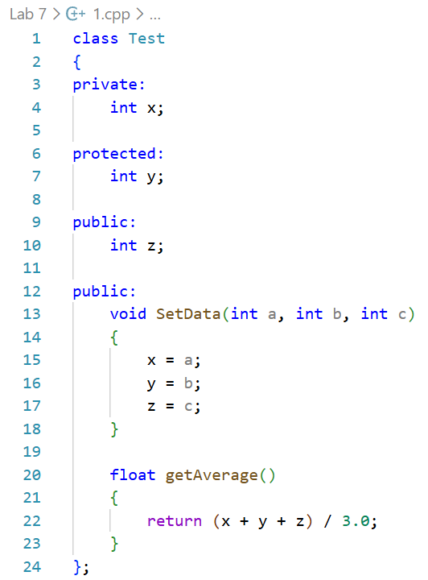
Procedure:
- The class Test was analyzed to identify data members (x, y, z) and member functions (SetData(), getAverage())
- Access specifiers (private, protected, public) of each member were noted
- A UML diagram was drawn with three compartments:
  - Top compartment for the class name
  - Middle compartment for data members with access symbols (- for private, # for protected, + for public)
  - Bottom compartment for member functions with access symbols and parameter lists
- Relationships, if any, would have been represented (not applicable in this single-class example)
Precautions:
- Correct access specifiers were ensured while labeling the data members and functions
- Function names and parameter types were correctly written in the UML diagram to avoid ambiguity
Conclusion:
The UML diagram effectively represented the Test class structure, showing private, protected, and public members along with their respective functions. This diagram provided a clear and visual understanding of the class design and encapsulation in C++.
Problem 2: UML: Aggregation
Objectives:
- To understand the concept of aggregation in object-oriented programming
- To implement a relationship where one class contains a reference to another class without owning its lifetime
Theory:
Aggregation represents a “has-a” relationship between two classes, where one class contains a reference (pointer or object) of another class but does not manage its lifetime. If the contained object (e.g., Patient) is destroyed, the container object (e.g., Doctor) still exists, demonstrating weak ownership. UML diagrams use a hollow diamond to show aggregation.
Code:
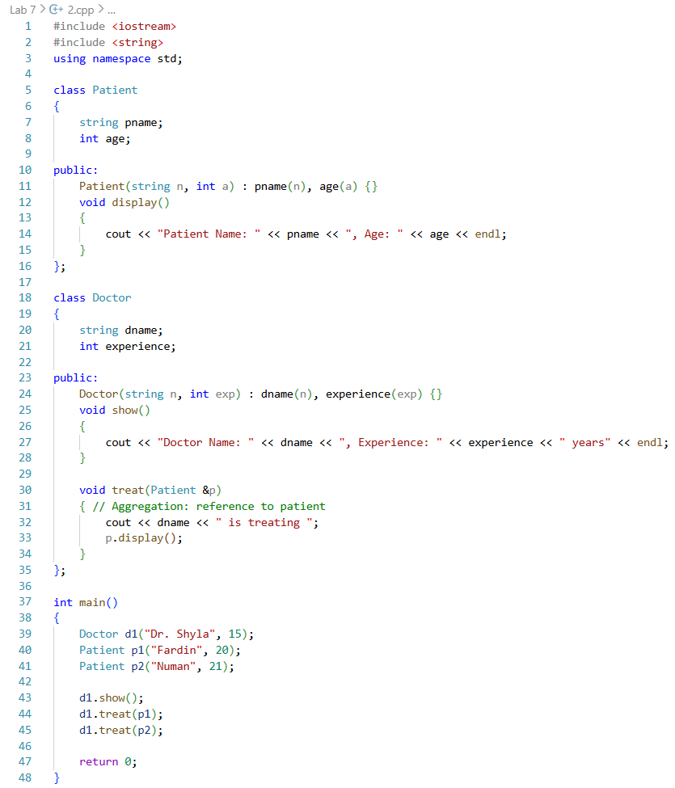
Procedure:
- Class Patient was created to store patient information (name and age)
- Class Doctor was created to store doctor information (name and experience)
- A method treat() in Doctor was created to accept a reference to a Patient object, establishing aggregation
- Doctor object was initialized independently of Patient objects
- Patient objects were created and passed to the Doctor object’s treat() method to demonstrate association
- Destruction of Patient objects would not affect the Doctor object, showing aggregation
Output:
Precautions:
- References or pointers were used to establish aggregation instead of creating objects inside the container class
- Proper initialization of objects was ensured to avoid dangling references or null pointer access
Conclusion:
Aggregation successfully demonstrated a “has-a” relationship where the Doctor class could interact with multiple Patient objects without owning them. This shows that contained objects can be destroyed independently while the container object continues to exist, as visualized in the UML diagram.
Problem 3: UML: Composition
Objectives:
- To understand the concept of composition in object-oriented programming
- To implement a relationship where one class owns another class entirely, and the lifetime of the contained object depends on the container class
Theory:
Composition represents a strong “has-a” relationship where one class owns another class. If the container object (e.g., Doctor) is destroyed, all contained objects (e.g., Patient) are automatically destroyed. UML diagrams use a filled diamond to show composition
Code:
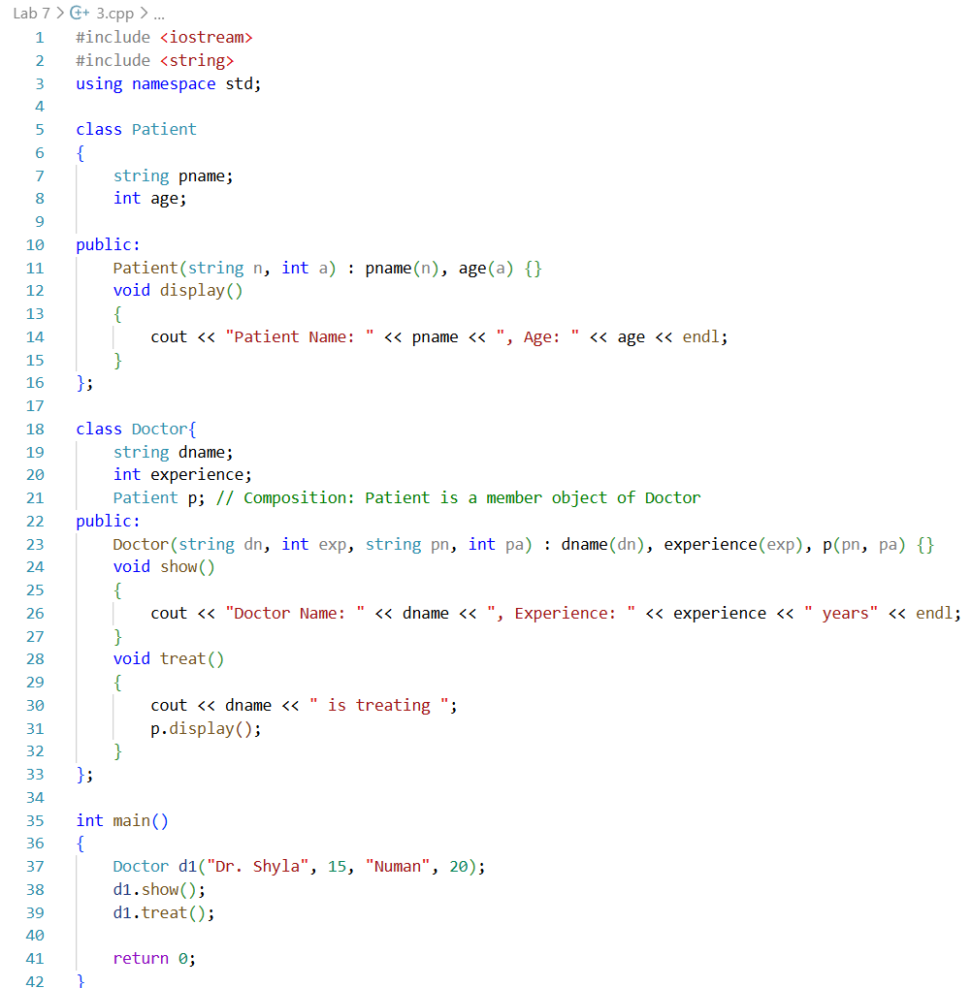
Procedure:
- Class Patient was created to store patient information (name and age)
- Class Doctor was created to store doctor information (name and experience)
- Patient object was declared as a member variable of Doctor to establish composition
- Doctor object was initialized, which automatically initialized the Patient object using the constructor
- Method treat() in Doctor was called to display information of the contained Patient object
- Upon destruction of the Doctor object, the Patient object was automatically destroyed, demonstrating strong ownership
Output:
Precautions:
- Proper constructor initialization of member objects was ensured to avoid uninitialized objects
- Composition was established by declaring the member object inside the class, not using references or pointers
Conclusion:
Composition successfully demonstrated a “owns-a” relationship where the Patient object existed only as part of the Doctor object. Destroying the Doctor object also destroyed the Patient object, confirming strong ownership and proper resource management, as represented in the UML diagram
Problem 4: Java Programming - Basics
Objectives:
- To practice basic Java programming concepts including input/output, conditionals, arrays, and loops
- To perform array operations like finding largest, smallest, average, searching, and sorting
Theory:
Java is an object-oriented programming language used for building portable, platform-independent applications. Basic programming tasks involve reading inputs, performing computations, using arrays to store data, and manipulating elements with loops and methods like sorting or searching
Code:
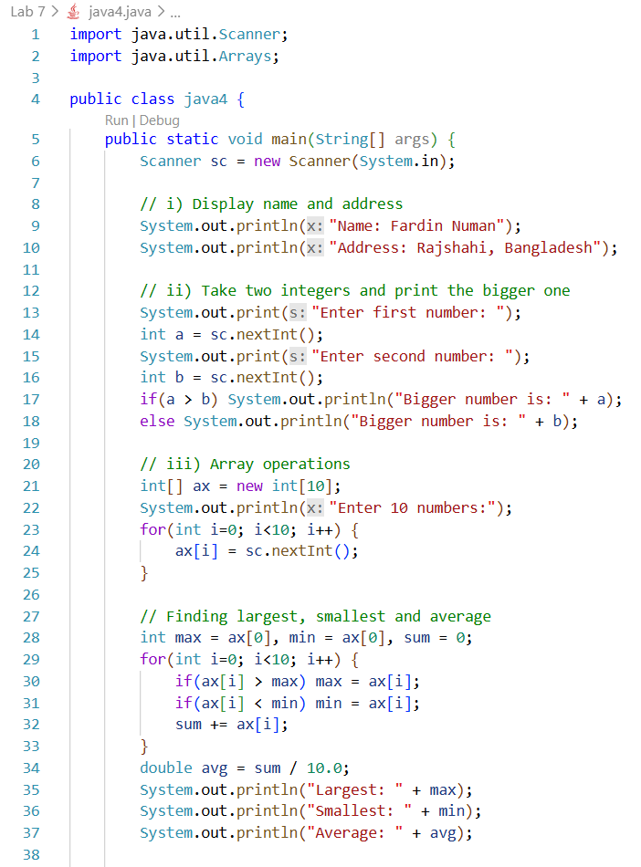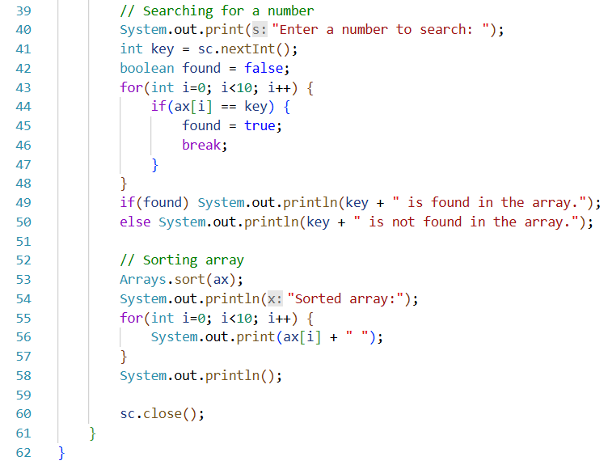

Procedure:
- Scanner class was used to take input from the user
- Name and address were printed using System.out.println()
- Two integers were read from the user and compared using an if-else statement to find the bigger one
- Array ax[] was declared to store 10 numbers, which were read from the user
- The largest and smallest numbers were determined by iterating through the array
- Sum of all elements was calculated to find the average
- Linear search was implemented to find a specific number in the array
- Arrays.sort() method was used to sort the array in ascending order
- Array elements were displayed after sorting
Output:
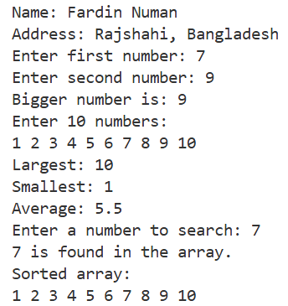
Precautions:
- Array indices were carefully used to avoid ArrayIndexOutOfBoundsException
- Inputs were validated for integer types to avoid runtime errors
Conclusion:
Basic Java programming concepts were successfully applied to display information, compare numbers, and perform array operations including finding largest, smallest, average, searching, and sorting. The program demonstrated fundamental control structures and array handling in Java.
Problem 5: Java Programming - Private Method
Objectives:
- To understand the concept of private methods in Java and their access restrictions
- To demonstrate that private methods can be invoked only inside the class they are defined in
Theory:
In Java, a private method is accessible only within the class in which it is declared. It cannot be called from outside the class or by derived classes. This encapsulation ensures data hiding and controlled access to internal functionalities of a class
Code:
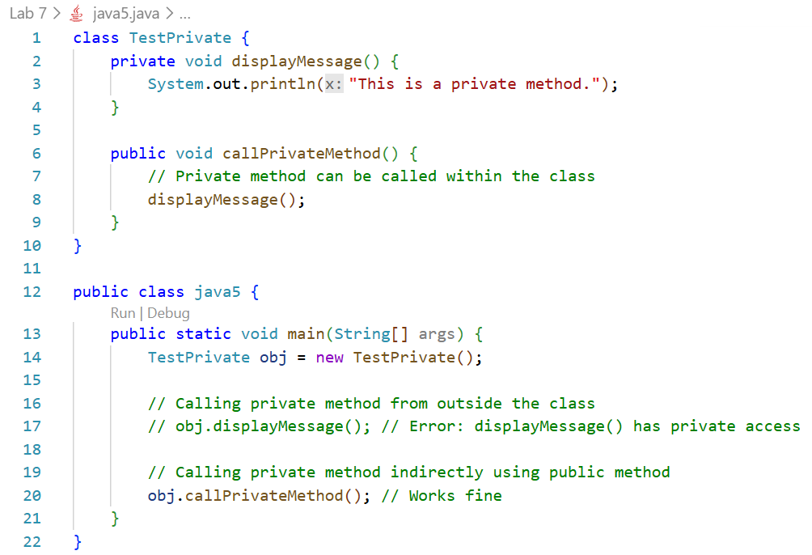
Procedure:
- Class TestPrivate was created with a private method displayMessage()
- A public method callPrivateMethod() was written to call the private method from inside the class
- In the main() method, an object of TestPrivate was created
- Attempt to call displayMessage() directly from main() was noted to be invalid (commented to prevent compilation error)
- Private method was successfully invoked indirectly through a public method
- Observations were made to verify that private methods cannot be accessed from outside the class
Output:
Precautions:
- Private methods were only called inside the class to prevent compilation errors
- Correct access modifiers were used to demonstrate encapsulation clearly
Conclusion:
Private methods were successfully shown to be accessible only within the class and not from outside. Indirect access through public methods allowed controlled execution, demonstrating data hiding and encapsulation in Java
Problem 6: Java Programming - Static Method/Member
Objectives:
- To understand the behavior of static methods and static members in Java
- To demonstrate that static methods can access only static members and cannot directly access non-static members
Theory:
In Java, static members (variables or methods) belong to the class rather than individual objects. Static methods can directly access other static members of the class but cannot access non-static (instance) members unless an object of the class is created. This ensures shared data and behavior across all objects
Code:
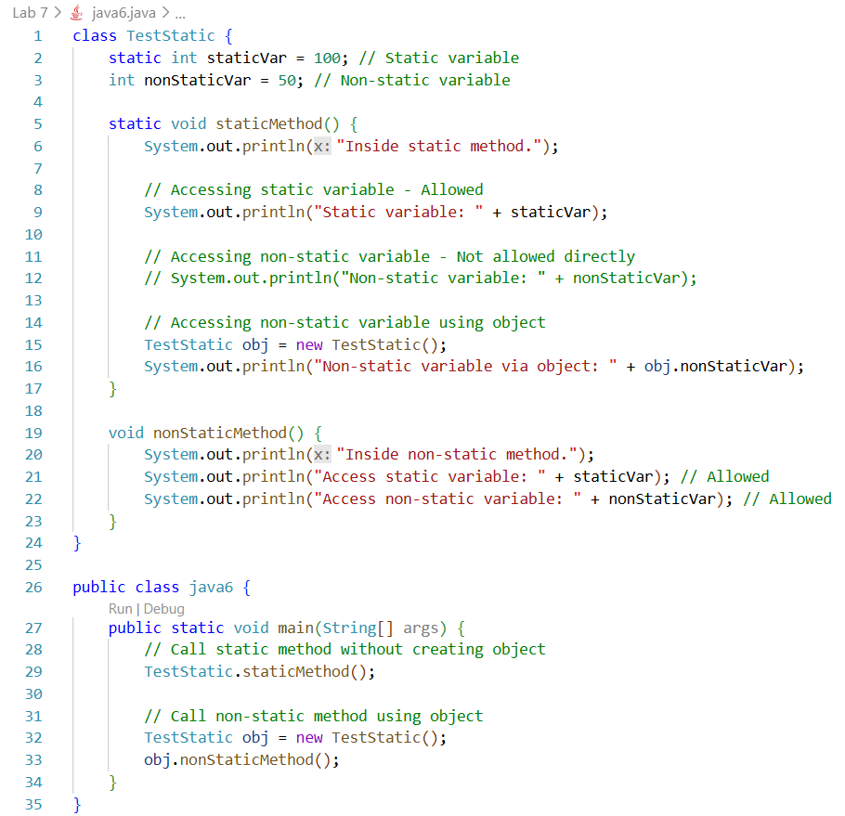
Procedure:
- Class TestStatic was created with a static variable staticVar and a non-static variable nonStaticVar
- A static method staticMethod() was written to access the static variable directly and the non-static variable through an object
- A non-static method nonStaticMethod() was written to access both static and non-static variables directly
- In main(), the static method was called without creating an object, demonstrating class-level access
- Non-static method was called using an object of the class, showing instance-level access
- Observations confirmed that static methods cannot access non-static members directly
Output:
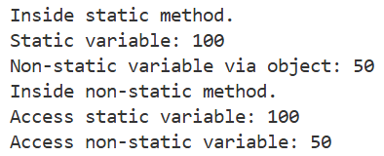
Precautions:
- Non-static members were accessed through objects to avoid compilation errors in static methods
- Static methods were invoked using the class name to demonstrate correct usage
Conclusion:
Static methods were shown to access static members directly and non-static members only through objects, confirming Java’s class-level behavior. This demonstrates proper use of static methods and members and the distinction between class-level and instance-level access

Problem 1: ArrayList Class
Objectives:
- To understand the use of ArrayList class for dynamic array management
- To implement common ArrayList methods like add(), get(), set(), remove(), size(), toString(), sort(), and clear().
Theory:
The ArrayList class in Java is a resizable array that allows dynamic storage of elements. It provides methods to add, access, modify, remove, sort, and clear elements efficiently. Unlike regular arrays, ArrayLists can grow or shrink at runtime, making them suitable for dynamic data management
Code:
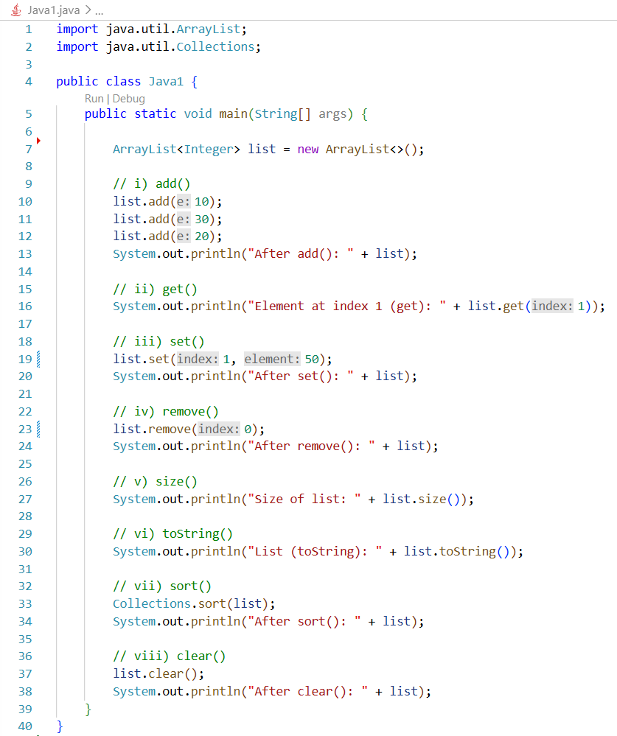
Procedure:
- ArrayList object list was declared to store Integer elements dynamically
- Elements were added using add() method
- Element at index 1 was accessed using get() method
- Element at index 1 was modified using set() method
- First element was removed using remove() method
- size() method was used to determine the number of elements
- toString() method was used to display the ArrayList contents
- ArrayList was sorted using Collections.sort()
- All elements were cleared using clear() method
Output:
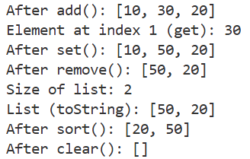
Precautions:
- Valid indices were ensured before using get(), set(), or remove() to prevent IndexOutOfBoundsException
- ArrayList methods were used correctly according to Java syntax to prevent runtime errors
Conclusion:
Java ArrayList provided dynamic storage and flexible management of integer elements. Methods like add(), get(), set(), remove(), size(), toString(), sort(), and clear() were successfully demonstrated, highlighting the convenience and efficiency of ArrayList over traditional arrays
Problem 2: Anonymous Object (MidPoint Method)
Objectives:
- To understand the use of anonymous objects in Java.
- To implement a method that calculates the midpoint of two Point objects.
Theory:
In Java, anonymous objects are objects created without being assigned to a reference variable. They are useful for one-time use. By passing objects directly to a method and returning a new object, operations like calculating the midpoint of two points can be performed efficiently without storing intermediate objects
Code:
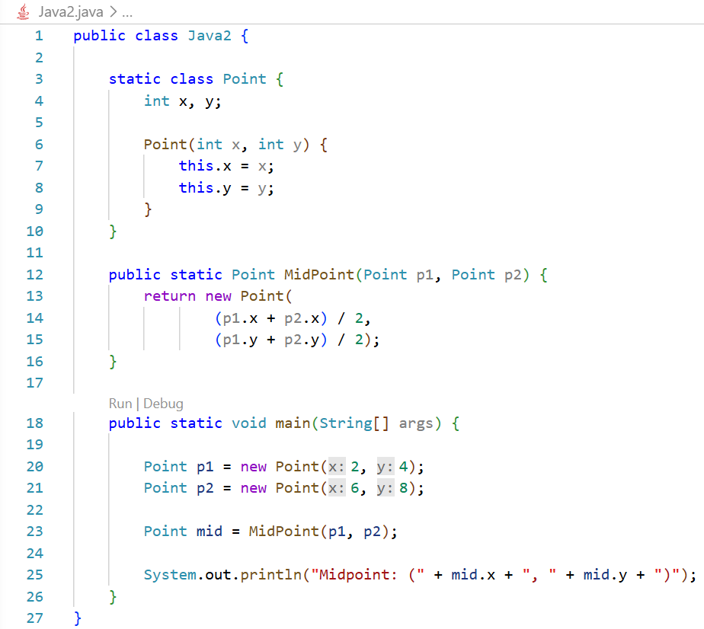
Procedure:
- Class Point was created with integer members x and y to represent coordinates
- Two Point objects p1 and p2 were initialized with given coordinates
- Method MidPoint() was defined to accept two Point objects and calculate their midpoint
- A new anonymous Point object was returned by MidPoint() containing the midpoint coordinates
- The returned midpoint object was stored in mid and its coordinates were displayed
Output:
Precautions:
- Valid Point objects were ensured to avoid NullPointerException
- Arithmetic operations were performed carefully to prevent incorrect midpoint calculation
Conclusion:
Anonymous objects were effectively used to calculate and return the midpoint of two points. The method MidPoint() demonstrated how objects can be passed and returned without explicitly storing intermediate objects, improving code clarity and efficiency
Problem 3: Inner Class
Objectives:
- To understand the concept of inner classes in Java
- To implement a method in the inner class that accesses private members of both inner and outer classes
Theory:
An inner class in Java is a class defined within another class. Inner classes can access the private members of the outer class directly. This allows encapsulation of functionality and simplifies operations like summing private data members of outer and inner classes without exposing them
Code:
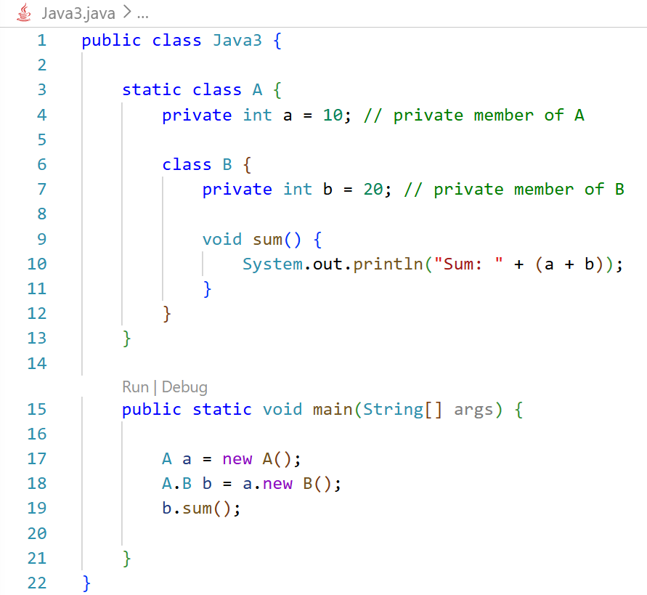
Procedure:
- Class A was created with private member a
- Inner class B was declared inside A with private member b
- Method sum() was defined in class B to calculate the sum of a (from outer class) and b (from inner class)
- Object a of class A was instantiated
- Object b of inner class B was created using the outer class object a
- Method sum() was invoked using the inner class object to display the sum of the private members
Output:
Precautions:
- Inner class object was created using the outer class instance to ensure correct access to outer class members
- Private members were accessed only through the inner class method to maintain encapsulation
Conclusion:
The inner class successfully accessed and used private members of both the outer and inner classes. The sum() method demonstrated how inner classes simplify operations on private data while keeping data encapsulated and secure
Problem 4: Inheritance: Use of super Keyword
Objectives:
- To understand the use of the super keyword in Java for accessing parent class members
- To implement inheritance and demonstrate access to parent class variables, methods, and constructors from a derived class
Theory:
In Java, the super keyword is used in a subclass to refer to the immediate parent class. It allows access to parent class variables, methods, and constructors, even when they are overridden or hidden in the subclass. This is useful for maintaining parent behavior while extending functionality

Code:
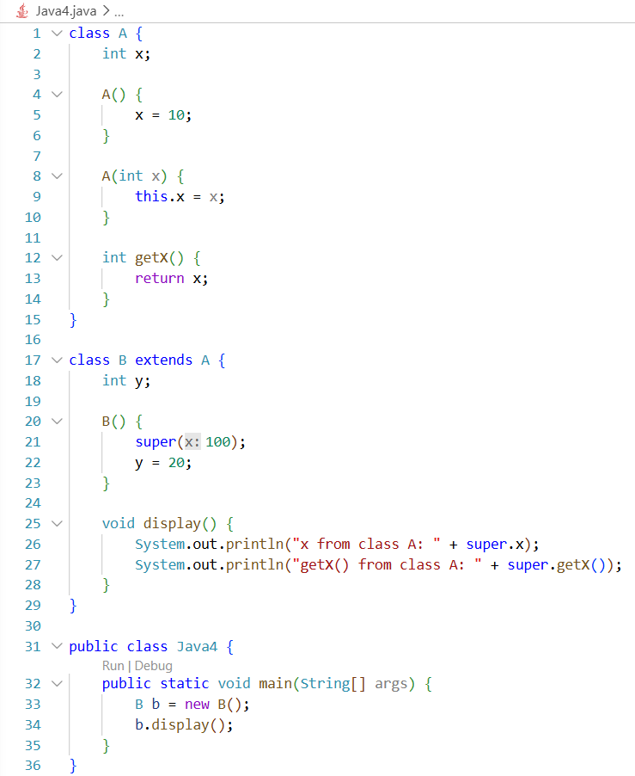
Procedure:
- Class A was created with member x and two constructors: default and parameterized
- Method getX() was defined in class A to return the value of x
- Class B was derived from A using extends
- Parameterized constructor of A was called in B using super(100)
- Member x of class A was accessed in class B using super.x
- Method getX() of class A was called in class B using super.getX()
- Object b of class B was created and display() method was invoked to print values
Output:
Precautions:
- The parameterized constructor of the parent class was called before initializing subclass members
- Parent class members were accessed using super to avoid ambiguity with subclass members
Conclusion:
The super keyword successfully accessed parent class variables, methods, and constructors from the subclass. Inheritance was demonstrated effectively, and super ensured correct interaction between parent and child class members while preserving encapsulation
Problem 5: Interface in Java
Objectives:
- To understand interface implementation and multiple inheritance behavior in Java
- To demonstrate calling interface methods through a class hierarchy
Theory:
In Java, a class can implement multiple interfaces and extend another class simultaneously. Interfaces define abstract methods that must be implemented in the derived class. This allows combining multiple contracts while supporting single class inheritance, providing flexibility without violating Java’s restriction on multiple class inheritance
Code:
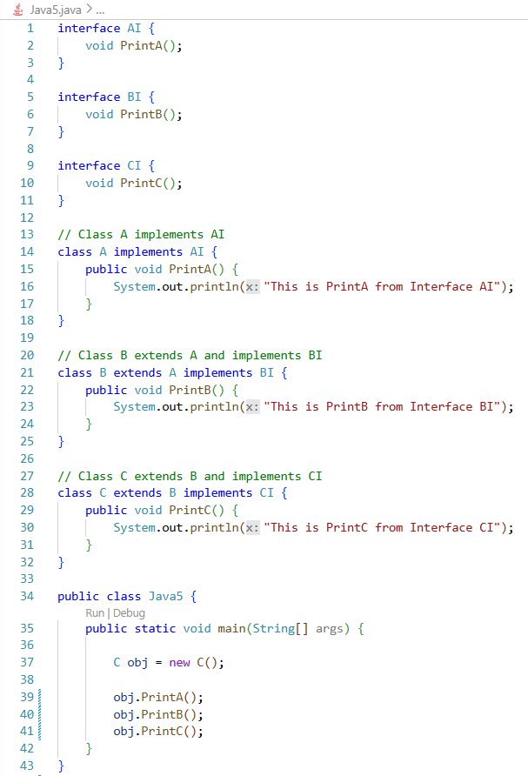
Procedure:
- Three interfaces AI, BI, and CI were declared with abstract methods PrintA(), PrintB(), and PrintC() respectively
- Class A was created to implement interface AI and override PrintA()
- Class B extended A and implemented interface BI, overriding PrintB()
- Class C extended B and implemented interface CI, overriding PrintC()
- Object obj of class C was created
- Methods PrintA(), PrintB(), and PrintC() were invoked using obj to demonstrate multiple interface method calls
Output:
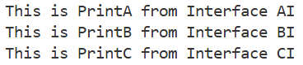
Precautions:
- Each interface method was properly implemented in the respective classes to prevent compilation errors
- Correct class hierarchy was maintained to allow seamless access to parent and interface methods
Conclusion:
Multiple interfaces were implemented successfully in a single class hierarchy. Class C was able to access methods from all interfaces via inheritance, demonstrating Java’s approach to combining single class inheritance with multiple interface implementation effectively

